**웹서버프로그래밍 개인프로젝트 개발완료보고서**

12204172 최현식

**1. 화면 설명 (스토리보드)**

주제 : 공모주 관련 정보 확인 사이트

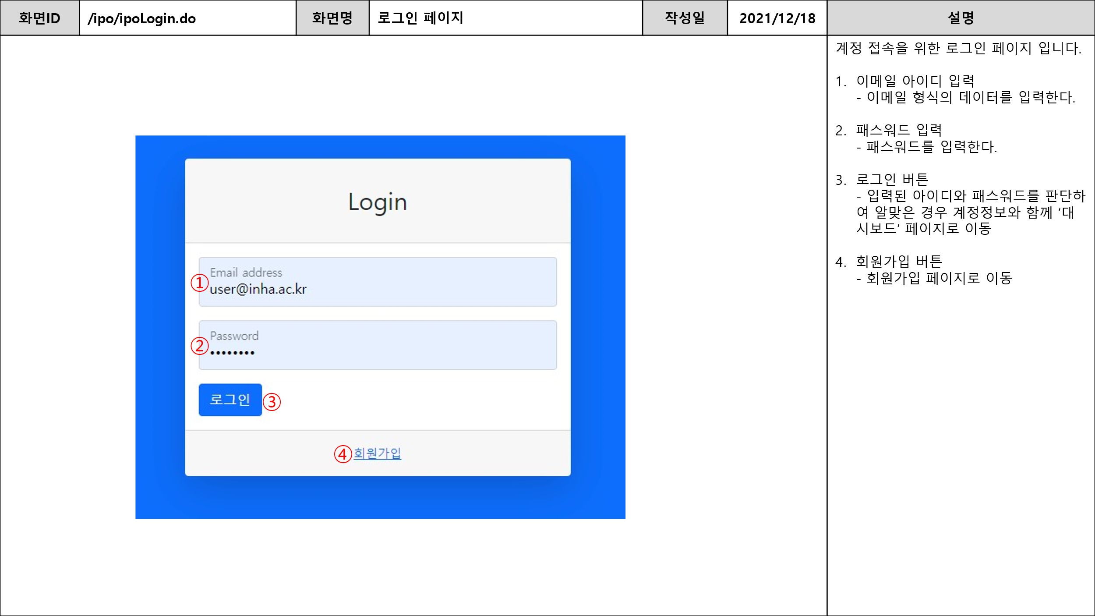

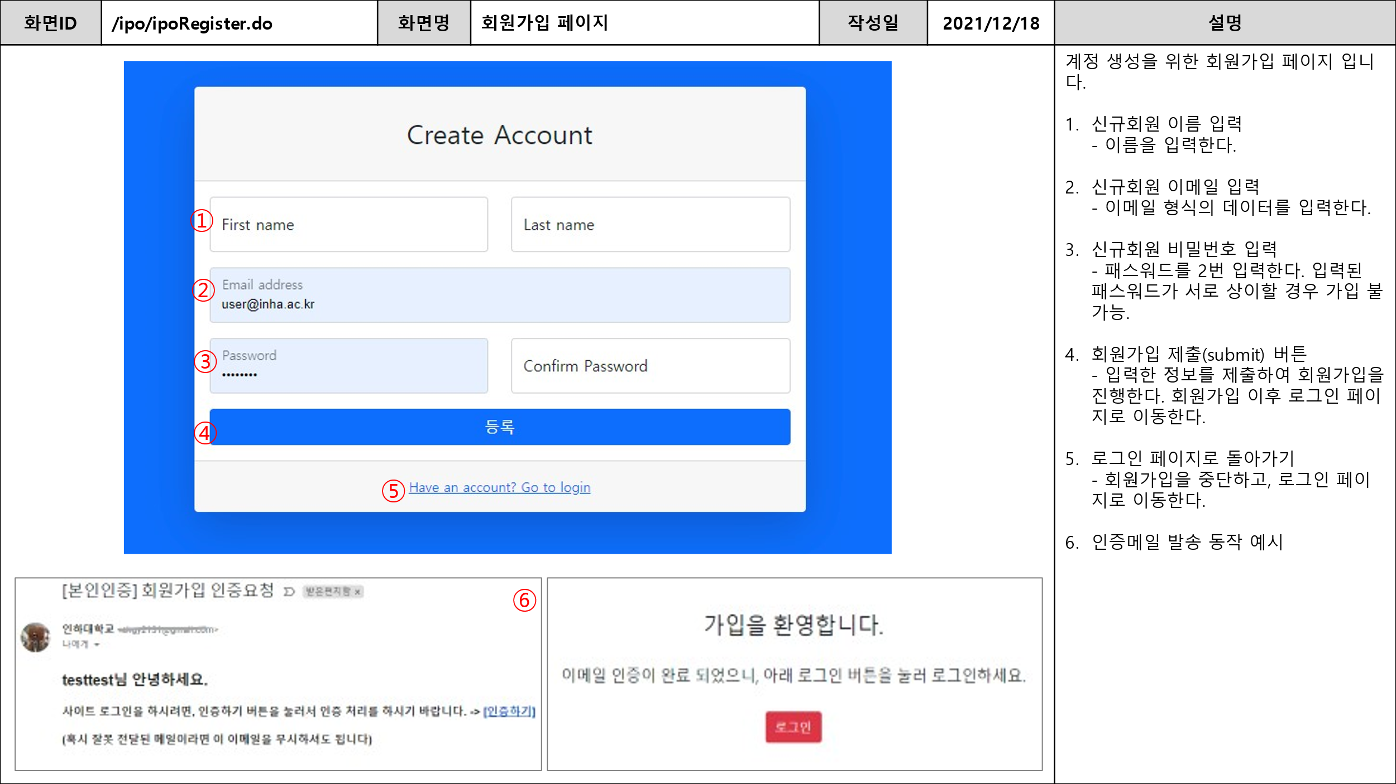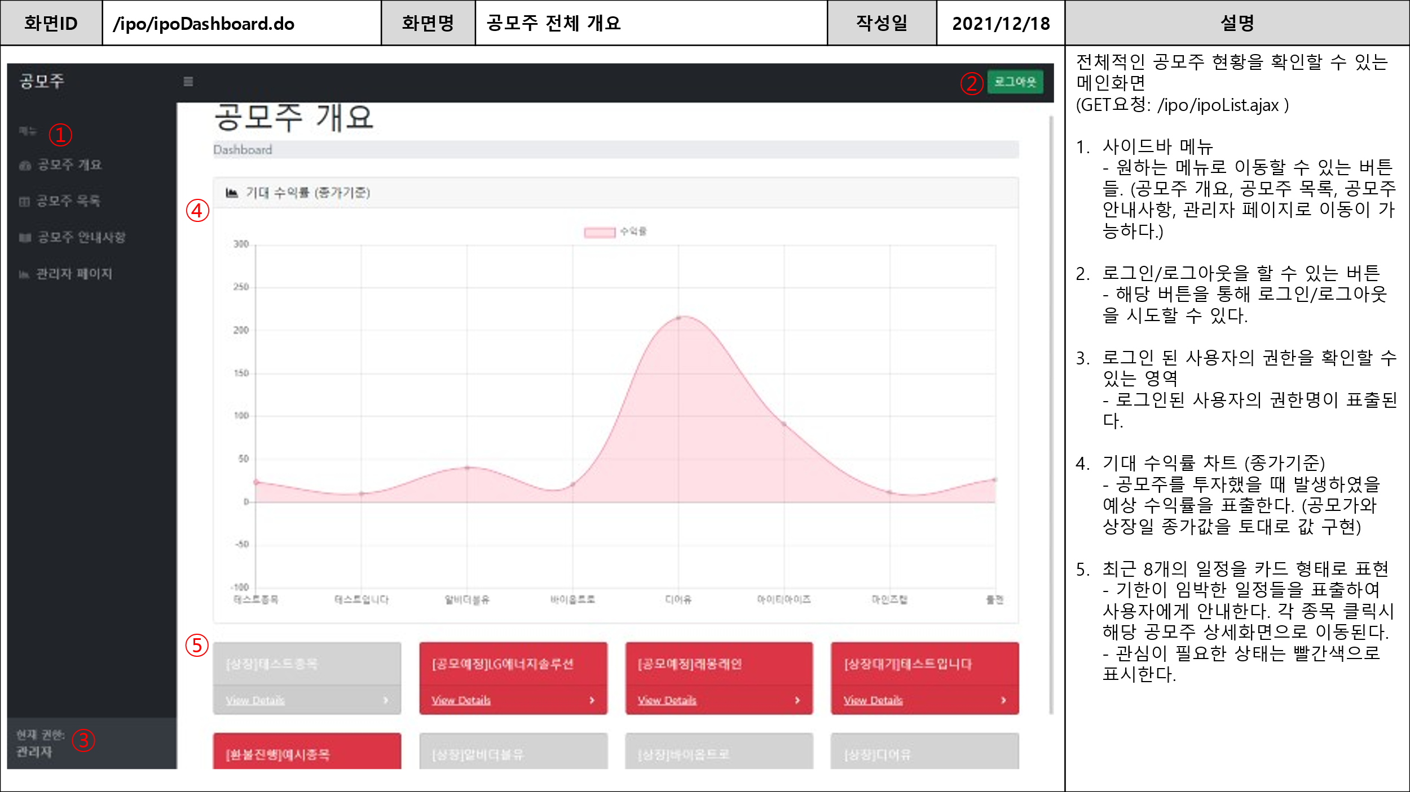

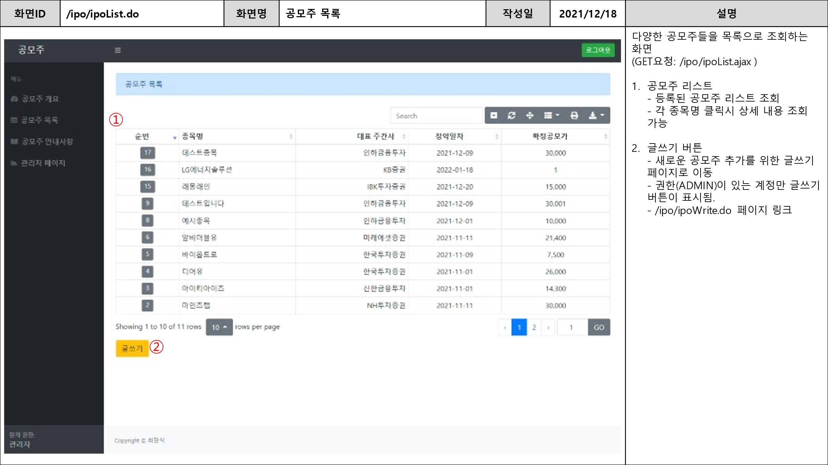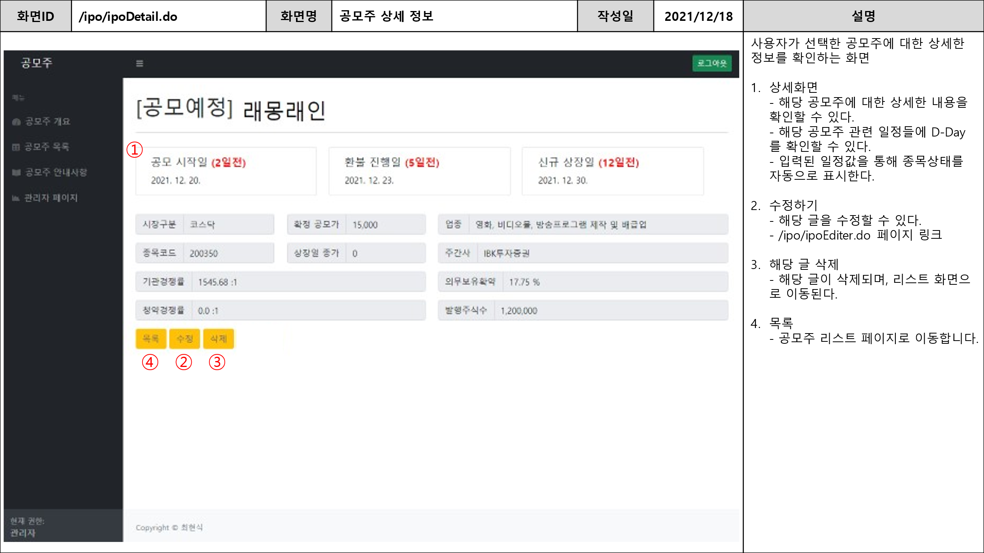

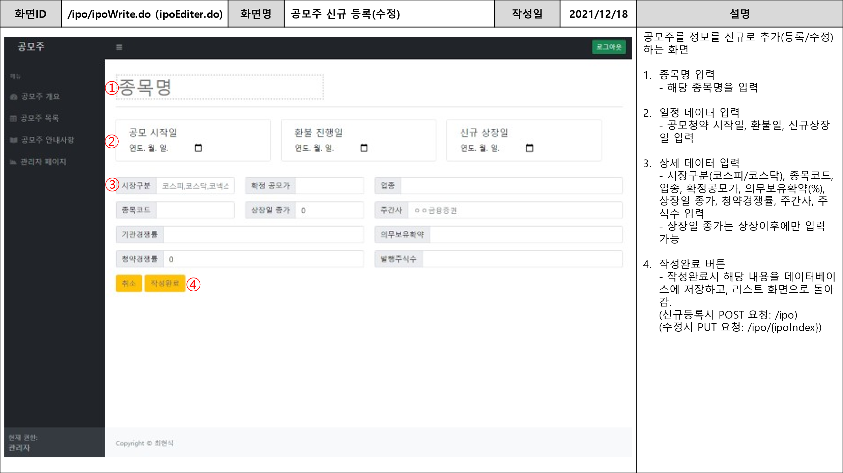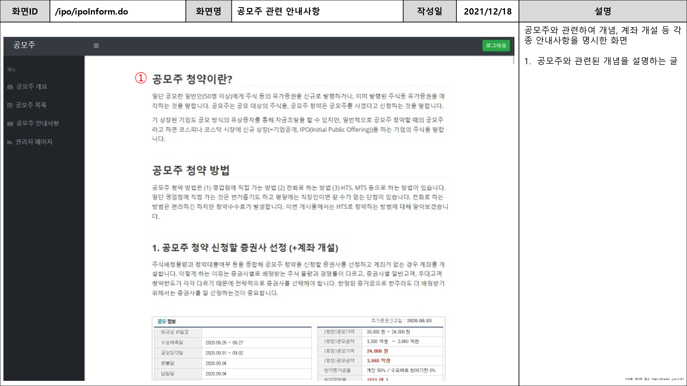

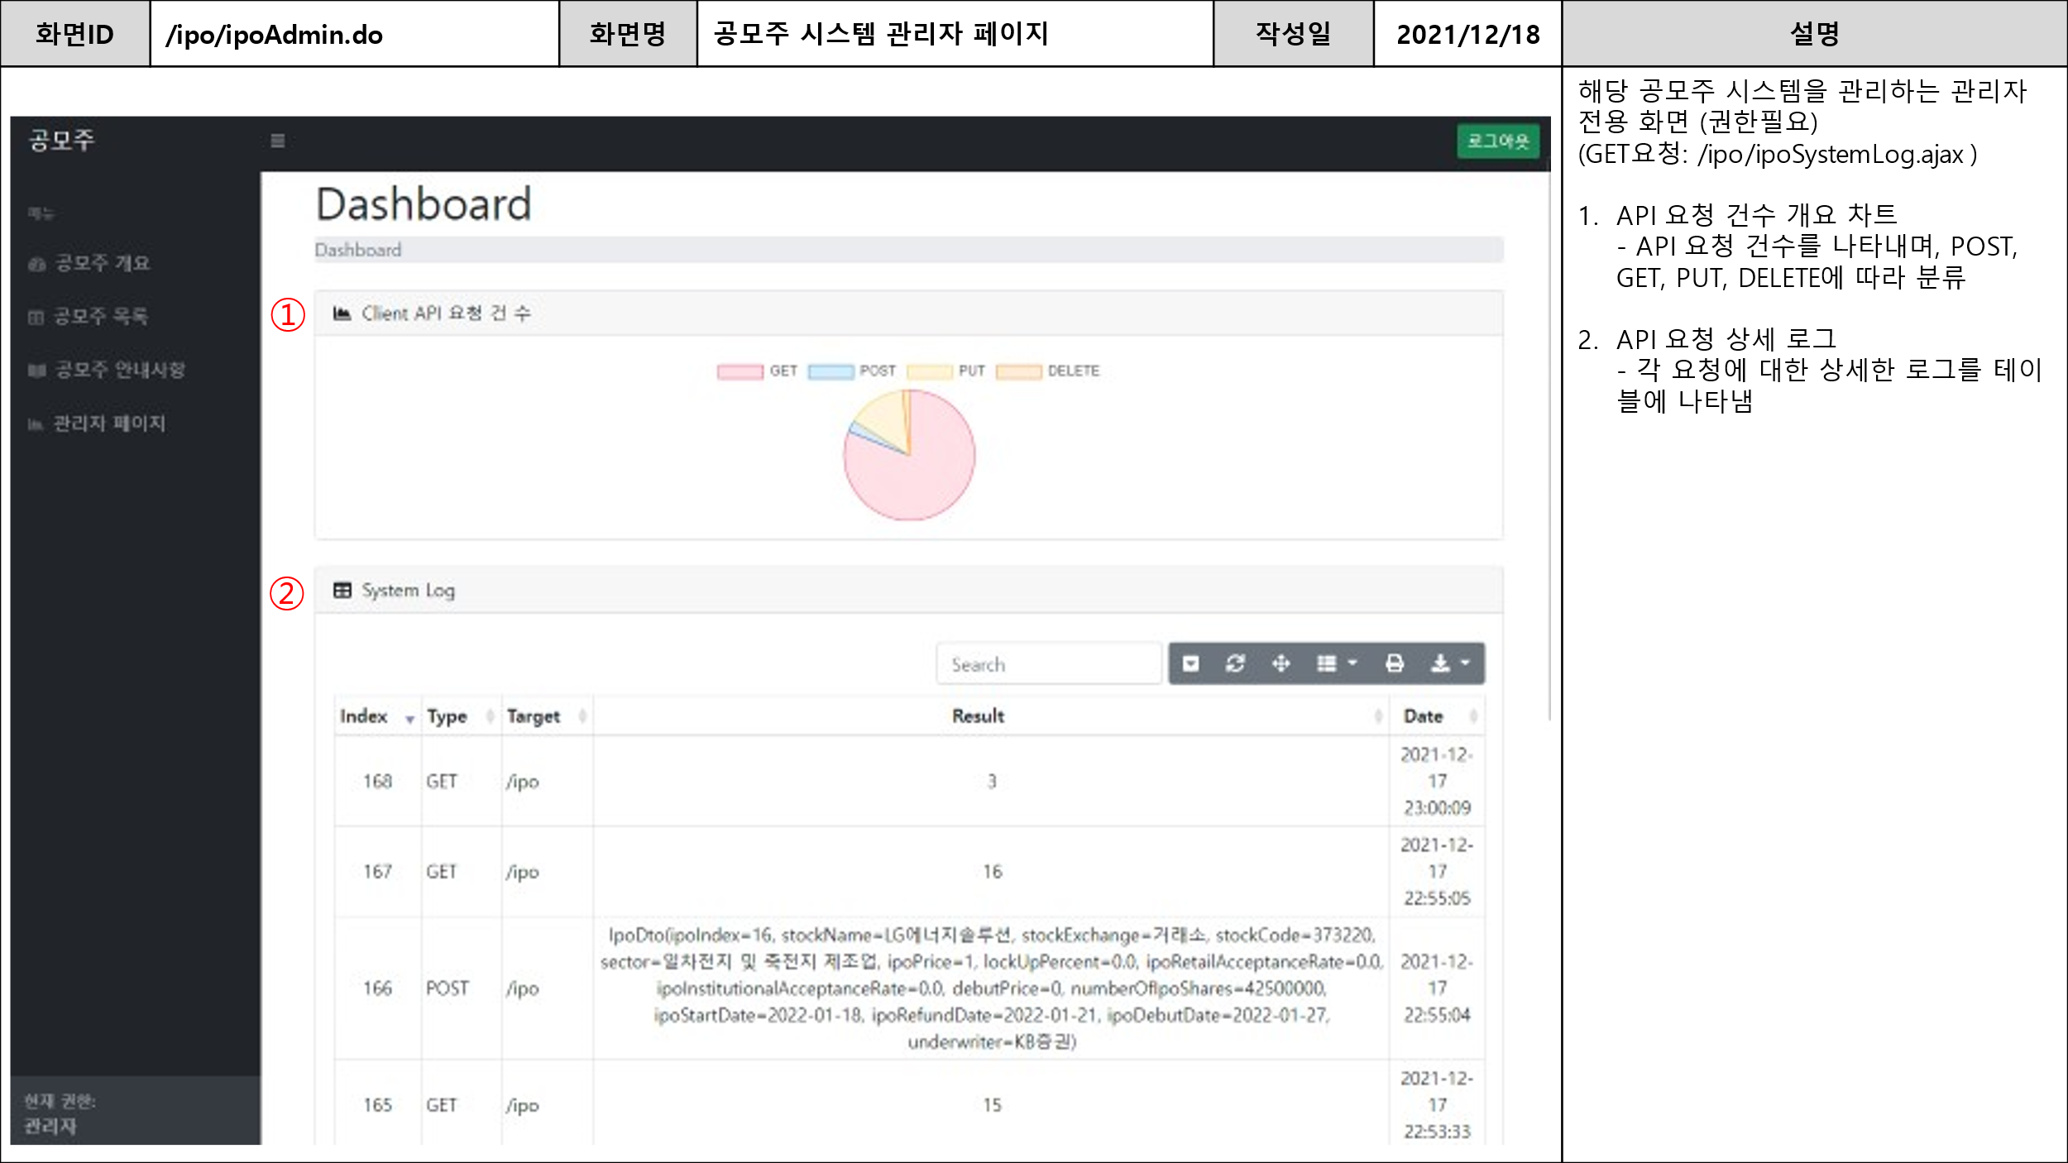

**2. 데이터베이스 테이블**

**2-1. members**

각 계정의 정보를 저장하는 테이블

**2.2. member_roles**

계정에 부여할 권한값을 저장해두는 테이블

**2.3 ipo**

공모주 관련 정보를 저장하는 테이블

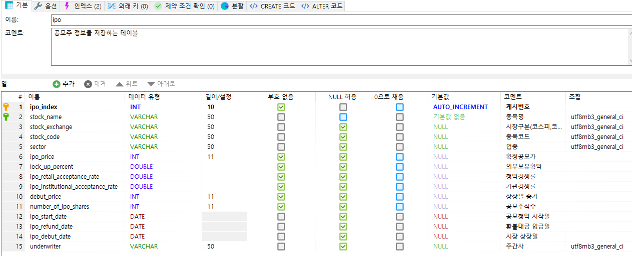

**2.4 system_log**

시스템 로그를 저장하는 테이블

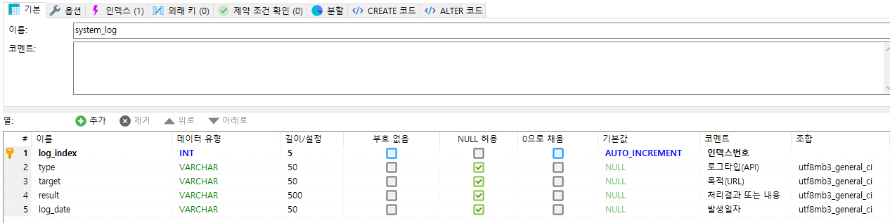

**3. 소스**

**3-1) Controller**

|  |
| --- |
| **IpoController** |
| **package kr.ac.inha.board.ipo.controller;**  **import java.util.List;**  **import org.springframework.beans.factory.annotation.Autowired;**  **import org.springframework.stereotype.Controller;**  **import org.springframework.web.bind.annotation.PathVariable;**  **import org.springframework.web.bind.annotation.RequestMapping;**  **import org.springframework.web.bind.annotation.RequestMethod;**  **import org.springframework.web.bind.annotation.RequestParam;**  **import org.springframework.web.bind.annotation.ResponseBody;**  **import org.springframework.web.servlet.ModelAndView;**  **import kr.ac.inha.board.ipo.dto.IpoDto;**  **import kr.ac.inha.board.ipo.dto.SystemLogDto;**  **import kr.ac.inha.board.ipo.service.IpoService;**  **import kr.ac.inha.board.ipo.service.SystemLogService;**  **import lombok.extern.slf4j.Slf4j;**  **@Slf4j**  **@Controller**  **public class IpoController {**  **@Autowired**  **private IpoService ipoService;**    **@Autowired**  **private SystemLogService systemLogService;**  **@RequestMapping(value = {"/ipo/ipoDashboard.do","/" })**  **public ModelAndView openIpoDashboard() throws Exception {**  **ModelAndView mv = new ModelAndView("/ipo/ipoDashboard");**  **return mv;**  **}**  **@RequestMapping("/ipo/ipoInform.do")**  **public ModelAndView openIpoInform() throws Exception {**  **ModelAndView mv = new ModelAndView("/ipo/ipoInform");**  **return mv;**  **}**  **@RequestMapping("/ipo/ipoAdmin.do")**  **public ModelAndView openIpoAdmin() throws Exception {**  **ModelAndView mv = new ModelAndView("/ipo/ipoAdmin");**  **return mv;**  **}**  **@RequestMapping("/ipo/ipoSystemLog.ajax")**  **@ResponseBody**  **public List<SystemLogDto> ipoSystemLogAjax() throws Exception {**  **List<SystemLogDto> list = systemLogService.selectSystemLog();**  **return list;**  **}**    **@RequestMapping("/ipo/ipoList.do")**  **public ModelAndView openIpoList() throws Exception {**  **ModelAndView mv = new ModelAndView("/ipo/ipoList");**    **return mv;**  **}**  **@RequestMapping("/ipo/ipoList.ajax")**  **@ResponseBody**  **public List<IpoDto> ipoListAjax() throws Exception {**  **List<IpoDto> list = ipoService.selectIpoList();**  **return list;**  **}**  **@RequestMapping("/ipo/ipoEditer.do")**  **public ModelAndView openIpoEditer(@RequestParam int ipoIndex) throws Exception {**  **ModelAndView mv = new ModelAndView("/ipo/ipoEditer");**  **log.warn("Start ipo Editer Controller");**  **IpoDto ipo = ipoService.selectIpoDetail(ipoIndex);**    **mv.addObject("ipo", ipo);**  **return mv;**  **}**  **@RequestMapping("/ipo/ipoWrite.do")**  **public ModelAndView openIpoWrite() throws Exception {**  **ModelAndView mv = new ModelAndView("/ipo/ipoWrite");**  **return mv;**  **}**  **@RequestMapping(value="/ipo", method=RequestMethod.POST)**  **public String insertIpo(IpoDto ipo) throws Exception {**  **log.warn("start POST controller => " + ipo);**  **ipoService.insertIpo(ipo);**    **systemLogService.writeLog("POST", "/ipo", ipo.toString());**  **return "redirect:/ipo/ipoList.do";**  **}**    **@RequestMapping(value="/ipo/{ipoIndex}", method=RequestMethod.PUT)**  **public String updateIpo(IpoDto ipo) throws Exception {**  **log.warn("start put controller => " + ipo);**  **ipoService.updateIpo(ipo);**    **systemLogService.writeLog("PUT", "/ipo", ipo.toString());**  **return "redirect:/ipo/"+Integer.toString(ipo.getIpoIndex());**  **}**    **@RequestMapping(value="/ipo/{ipoIndex}", method=RequestMethod.DELETE)**  **public String deleteIpo(IpoDto ipo) throws Exception {**  **ipoService.deleteIpo(ipo.getIpoIndex());**  **systemLogService.writeLog("DELETE", "/ipo", ipo.toString());**  **return "redirect:/ipo/ipoList.do";**  **}**    **@RequestMapping(value="/ipo/{ipoIndex}", method=RequestMethod.GET)**  **public ModelAndView openIpoDetail(@PathVariable("ipoIndex") int ipoIndex) throws Exception {**  **ModelAndView mv = new ModelAndView("/ipo/ipoDetail");**    **IpoDto ipo = ipoService.selectIpoDetail(ipoIndex);**  **mv.addObject("ipo", ipo);**  **log.warn("IpoDetail Result <= " + mv);**    **systemLogService.writeLog("GET", "/ipo", Integer.toString(ipoIndex));**  **return mv;**  **}**  **}** |

**3-2) Service**

|  |
| --- |
| **IpoService** |
| **package kr.ac.inha.board.ipo.service;**  **import java.util.List;**  **import kr.ac.inha.board.ipo.dto.IpoDto;**  **public interface IpoService {**  **List<IpoDto> selectIpoList() throws Exception;**  **IpoDto selectIpoDetail(int ipoIndex) throws Exception;**  **void deleteIpo(int ipoIndex) throws Exception;**  **void updateIpo(IpoDto ipo) throws Exception;**  **void insertIpo(IpoDto ipo) throws Exception;**  **}** |
| **IpoServiceImpl** |
| **package kr.ac.inha.board.ipo.service;**  **import java.util.List;**  **import org.springframework.beans.factory.annotation.Autowired;**  **import org.springframework.stereotype.Service;**  **import kr.ac.inha.board.ipo.dto.IpoDto;**  **import kr.ac.inha.board.ipo.mapper.IpoMapper;**  **import lombok.extern.slf4j.Slf4j;**  **@Slf4j**  **@Service**  **public class IpoServiceImpl implements IpoService {**  **@Autowired**  **private IpoMapper ipoMapper;**    **@Override**  **public List<IpoDto> selectIpoList() throws Exception {**  **return ipoMapper.selectIpoList();**  **}**    **@Override**  **public IpoDto selectIpoDetail(int ipoIndex) throws Exception {**  **log.warn("ipoDetail IpoIndex number => "+Integer.toString(ipoIndex));**  **IpoDto result = ipoMapper.selectIpoDetail(ipoIndex);**  **log.warn("Query Return Value <= " + result);**  **return result;**  **}**    **@Override**  **public void deleteIpo(int ipoIndex) throws Exception {**  **log.warn("start delete service");**  **ipoMapper.deleteIpo(ipoIndex);**  **}**    **@Override**  **public void updateIpo(IpoDto ipo) throws Exception {**  **log.warn("start put service <= " + ipo);**  **ipoMapper.updateIpo(ipo);**  **}**    **@Override**  **public void insertIpo(IpoDto ipo) throws Exception {**  **ipoMapper.insertIpo(ipo);**  **}**    **}** |

|  |
| --- |
| **SystemLogService** |
| **package kr.ac.inha.board.ipo.service;**  **import java.util.List;**  **import kr.ac.inha.board.ipo.dto.SystemLogDto;**  **public interface SystemLogService {**  **List<SystemLogDto> selectSystemLog() throws Exception;**  **void writeLog(String type, String target, String result) throws Exception;**  **}** |
| **SystemLogServiceImpl** |
| **package kr.ac.inha.board.ipo.service;**  **import java.util.List;**  **import org.springframework.beans.factory.annotation.Autowired;**  **import org.springframework.stereotype.Service;**  **import kr.ac.inha.board.ipo.dto.SystemLogDto;**  **import kr.ac.inha.board.ipo.mapper.IpoMapper;**  **import lombok.extern.slf4j.Slf4j;**  **@Slf4j**  **@Service**  **public class SystemLogServiceImpl implements SystemLogService{**  **@Autowired**  **private IpoMapper ipoMapper;**  **@Override**  **public List<SystemLogDto> selectSystemLog() throws Exception {**  **return ipoMapper.selectSystemLog();**  **}**    **@Override**  **public void writeLog(String type, String target, String result) throws Exception {**  **log.warn("");**  **ipoMapper.insertSystemLog(type, target, result);**  **}**    **}** |

**3-3) Mapper**

|  |
| --- |
| **IpoMapper** |
| **package kr.ac.inha.board.ipo.mapper;**  **import java.util.List;**  **import org.apache.ibatis.annotations.Mapper;**  **import org.apache.ibatis.annotations.Param;**  **import kr.ac.inha.board.ipo.dto.IpoDto;**  **import kr.ac.inha.board.ipo.dto.SystemLogDto;**  **@Mapper**  **public interface IpoMapper {**  **List<IpoDto> selectIpoList() throws Exception;**  **IpoDto selectIpoDetail(int ipoIndex) throws Exception;**  **void deleteIpo(int ipoIndex) throws Exception;**  **void updateIpo(IpoDto ipo) throws Exception;**  **void insertIpo(IpoDto ipo) throws Exception;**  **List<SystemLogDto> selectSystemLog() throws Exception;**  **//void insertSystemLog(String type, String target, String result) throws Exception;**  **void insertSystemLog(@Param("type") String type,@Param("target") String target,@Param("result") String result) throws Exception;**  **}** |

**3-4) Template**

|  |
| --- |
| **/layout/default_layout.html** |
| <!DOCTYPE html>  <html lang="ko"  xmlns:th="http://www.thymeleaf.org"  xmlns:layout="http://www.ultraq.net.nz/thymeleaf/layout"  xmlns:sec="http://www.thymeleaf.org/extras/spring-security"  >  <head>  <meta charset="utf-8" />  <meta http-equiv="X-UA-Compatible" content="IE=edge" />  <meta name="viewport" content="width=device-width, initial-scale=1, shrink-to-fit=no" />  <meta name="description" content="" />  <meta name="author" content="" />  <meta name="_csrf" th:content="${_csrf.token}"/>  <meta name="_csrf_header" th:content="${_csrf.headerName}"/>  <title layout:title-pattern="$LAYOUT_TITLE - $CONTENT_TITLE">공모주</title>  <link href="/css/styles.css" rel="stylesheet" />  <link rel="stylesheet" href="https://stackpath.bootstrapcdn.com/bootstrap/4.3.1/css/bootstrap.min.css">  <link rel="stylesheet" href="https://use.fontawesome.com/releases/v5.6.3/css/all.css">  </head>  <body>  <nav class="sb-topnav navbar navbar-expand navbar-dark bg-dark">  <!-- Navbar Brand-->  <a class="navbar-brand ps-3" href="/">공모주</a>  <!-- Sidebar Toggle-->  <button class="btn btn-link btn-sm order-1 order-lg-0 me-4 me-lg-0" id="sidebarToggle" href="#!"><i class="fas fa-bars"></i></button>  <!-- Navbar Search-->  <form class="d-none d-md-inline-block form-inline ms-auto me-0 me-md-3 my-2 my-md-0">  <!--  <div class="input-group">  <input class="form-control" type="text" placeholder="Search for..." aria-label="Search for..." aria-describedby="btnNavbarSearch" />  <button class="btn btn-primary" id="btnNavbarSearch" type="button"><i class="fas fa-search"></i></button>  </div>  -->  </form>  <!-- Navbar-->  <button sec:authorize="isAnonymous()" type="button" id="goLogin" class="btn btn-success btn-sm">로그인</button>  <button sec:authorize="not isAnonymous()" type="button" id="goLogout" class="btn btn-success btn-sm">로그아웃</button>  <!--  <ul class="navbar-nav ms-auto ms-md-0 me-3 me-lg-4">  <li class="nav-item dropdown">  <a class="nav-link dropdown-toggle" id="navbarDropdown" href="#" role="button" data-bs-toggle="dropdown" aria-expanded="false"><i class="fas fa-user fa-fw"></i></a>  <ul class="dropdown-menu dropdown-menu-end" aria-labelledby="navbarDropdown">  <li><a class="dropdown-item" href="#!">Settings</a></li>  <li><a class="dropdown-item" href="#!">Activity Log</a></li>  <li><hr class="dropdown-divider" /></li>  <li><a class="dropdown-item" href="#!">Logout</a></li>  </ul>  </li>  </ul>  -->  </nav>  <div id="layoutSidenav">  <div id="layoutSidenav_nav">  <nav class="sb-sidenav accordion sb-sidenav-dark" id="sidenavAccordion">  <div class="sb-sidenav-menu">  <div class="nav">  <div class="sb-sidenav-menu-heading">메뉴</div>  <a sec:authorize="hasAnyRole('USER', 'ADMIN')" class="nav-link" href="/ipo/ipoDashboard.do">  <div class="sb-nav-link-icon"><i class="fas fa-tachometer-alt"></i></div>  공모주 개요  </a>  <a sec:authorize="hasAnyRole('USER', 'ADMIN')" class="nav-link" href="/ipo/ipoList.do">  <div class="sb-nav-link-icon"><i class="fas fa-table"></i></div>  공모주 목록  </a>  <a sec:authorize="hasAnyRole('USER', 'ADMIN')" class="nav-link" href="/ipo/ipoInform.do">  <div class="sb-nav-link-icon"><i class="fas fa-book-open"></i></div>  공모주 안내사항  </a>  <a sec:authorize="hasRole('ADMIN')" class="nav-link" href="/ipo/ipoAdmin.do">  <div class="sb-nav-link-icon"><i class="fas fa-chart-area"></i></div>  관리자 페이지  </a>  </div>  </div>  <div class="sb-sidenav-footer">  <div class="small">현재 권한:</div>  <b sec:authorize="hasRole('ADMIN')">관리자</b>  <b sec:authorize="hasRole('USER')">사용자</b>  <b sec:authorize="hasRole('GUEST')">GUEST</b>  </div>  </nav>  </div>  <div id="layoutSidenav_content">  <main>  <div class="container-fluid px-4" layout:fragment="content">  Page Content 여기에 나올거에요. / 만약 이 글자가 보이면 제대로 로딩되지 못했습니다.  </div>  </main>  <footer class="py-4 bg-light mt-auto">  <div class="container-fluid px-4">  <div class="d-flex align-items-center justify-content-between small">  <div class="text-muted">Copyright &copy; 최현식</div>  <!--  <div>  <a href="#">Privacy Policy</a>  &middot;  <a href="#">Terms &amp; Conditions</a>  </div>  -->  </div>  </div>  </footer>  </div>  </div>  <!--팝업형식으로 로그아웃버튼이 호출됨-->  <div class="modal fade" id="logoutModal" tabindex="-1" role="dialog" aria-labelledby="exampleModalLabel"  aria-hidden="true">  <div class="modal-dialog" role="document">  <div class="modal-content">  <div class="modal-header">  <h5 class="modal-title" id="exampleModalLabel">정말 로그아웃 할까요?</h5>  <button class="close" type="button" data-dismiss="modal" aria-label="Close">  <span aria-hidden="true">×</span>  </button>  </div>  <div class="modal-body">'Logout' 선택시 세션이 종료됩니다.</div>  <div class="modal-footer">  <button class="btn btn-secondary" type="button" data-dismiss="modal">Cancel</button>  <form method="post" action="/logout"> <!--스프링 시큐리티 내부에서 관리되는 로그아웃측으로 전송됨-->  <input type="hidden" th:name="${_csrf.parameterName}" th:value="${_csrf.token}" />  <button type="submit" class="btn btn-primary">Logout</button>  </form>  </div>  </div>  </div>  </div>  <script src="https://cdn.jsdelivr.net/npm/jquery/dist/jquery.min.js"></script>  <script src="https://cdn.jsdelivr.net/npm/popper.js@1.16.0/dist/umd/popper.min.js"></script>  <script src="https://stackpath.bootstrapcdn.com/bootstrap/4.3.1/js/bootstrap.min.js"></script>  <script src="/js/scripts.js"></script>  <script>  //해당 csrf 토큰값은 상단에 <meta>로 넣어둘경우 spring-security가 알아서 값을 넣어준다.  var token = $("meta[name='_csrf']").attr("content");  var header = $("meta[name='_csrf_header']").attr("content");  $(document).ajaxSend(function (e, xhr, opt) {  xhr.setRequestHeader(header, token);  });  $("#goLogin").on('click', function () {  window.location.href = "/login/login.do";  });  $("#goLogout").on('click', function () {  $("#logoutModal").modal();  });  </script>  <th:block layout:fragment="script"></th:block>  </body>  </html> |
| **/login/login.html** |
| <!DOCTYPE html>  <html lang="en" xmlns:th="http://www.thymeleaf.org">  <head>  <meta charset="utf-8" />  <meta http-equiv="X-UA-Compatible" content="IE=edge" />  <meta name="viewport" content="width=device-width, initial-scale=1, shrink-to-fit=no" />  <meta name="description" content="" />  <meta name="author" content="" />  <title>로그인</title>  <link href="/css/styles.css" rel="stylesheet" />  <script src="https://cdnjs.cloudflare.com/ajax/libs/font-awesome/5.15.3/js/all.min.js" crossorigin="anonymous"></script>  </head>  <body class="bg-primary">  <div id="layoutAuthentication">  <div id="layoutAuthentication_content">  <main>  <div class="container">  <div class="row justify-content-center">  <div class="col-lg-5">  <div class="card shadow-lg border-0 rounded-lg mt-5">  <div class="card-header"><h3 class="text-center font-weight-light my-4">Login</h3></div>  <div class="card-body">  <form method="post">  <div class="form-floating mb-3">  <input class="form-control" id="username" name="username" type="email" placeholder="name@example.com" />  <label for="inputEmail">Email address</label>  </div>  <div class="form-floating mb-3">  <input class="form-control" id="password" name="password" type="password" placeholder="Password" />  <label for="inputPassword">Password</label>  </div>  <!--  <div class="form-check mb-3">  <input class="form-check-input" id="inputRememberPassword" type="checkbox" value="" />  <label class="form-check-label" for="inputRememberPassword">Remember Password</label>  </div>  <div class="d-flex align-items-center justify-content-between mt-4 mb-0">  <a class="small" href="password.html">Forgot Password?</a>  </div>  -->  <input type="hidden" th:name="${_csrf.parameterName}" th:value="${_csrf.token}" /> <!-- 토근이 없다면 403 오류일어남(비정상접근) -->  <button type="submit" class="btn btn-primary">로그인</button>  </form>  </div>  <div class="card-footer text-center py-3">  <div class="small"><a href="/login/register.do">회원가입</a></div>  </div>  </div>  </div>  </div>  </div>  </main>  </div>  <!--  <div id="layoutAuthentication_footer">  <footer class="py-4 bg-light mt-auto">  <div class="container-fluid px-4">  <div class="d-flex align-items-center justify-content-between small">  <div class="text-muted">Copyright &copy; Your Website 2021</div>  <div>  <a href="#">Privacy Policy</a>  &middot;  <a href="#">Terms &amp; Conditions</a>  </div>  </div>  </div>  </footer>  </div>  -->  </div>  <script src="https://cdn.jsdelivr.net/npm/bootstrap@5.1.3/dist/js/bootstrap.bundle.min.js" crossorigin="anonymous"></script>  <script src="/js/scripts.js"></script>  </body>  </html> |
| **/login/register.html** |
| <!DOCTYPE html>  <html lang="en" xmlns:th="http://www.thymeleaf.org">  <head>  <meta charset="utf-8" />  <meta http-equiv="X-UA-Compatible" content="IE=edge" />  <meta name="viewport" content="width=device-width, initial-scale=1, shrink-to-fit=no" />  <meta name="description" content="" />  <meta name="author" content="" />  <title>회원가입</title>  <link href="/css/styles.css" rel="stylesheet" />  <script src="https://cdnjs.cloudflare.com/ajax/libs/font-awesome/5.15.3/js/all.min.js" crossorigin="anonymous"></script>  </head>  <body class="bg-primary">  <div id="layoutAuthentication">  <div id="layoutAuthentication_content">  <main>  <div class="container">  <div class="row justify-content-center">  <div class="col-lg-7">  <div class="card shadow-lg border-0 rounded-lg mt-5">  <div class="card-header"><h3 class="text-center font-weight-light my-4">Create Account</h3></div>  <div class="card-body">  <form method="post"> <!-- ajax 처리를 위해서 반드시 post method 입력 -->  <div class="row mb-3">  <div class="col-md-6">  <div class="form-floating mb-3 mb-md-0">  <input class="form-control" id="inputFirstName" type="text" placeholder="Enter your first name" />  <label for="inputFirstName">First name</label>  </div>  </div>  <div class="col-md-6">  <div class="form-floating">  <input class="form-control" id="inputLastName" type="text" placeholder="Enter your last name" />  <label for="inputLastName">Last name</label>  </div>  </div>  </div>  <div class="form-floating mb-3">  <input class="form-control" id="inputEmail" type="email" placeholder="name@example.com" />  <label for="inputEmail">Email address</label>  </div>  <div class="row mb-3">  <div class="col-md-6">  <div class="form-floating mb-3 mb-md-0">  <input class="form-control" id="inputPassword" type="password" placeholder="Create a password" />  <label for="inputPassword">Password</label>  </div>  </div>  <div class="col-md-6">  <div class="form-floating mb-3 mb-md-0">  <input class="form-control" id="inputPasswordConfirm" type="password" placeholder="Confirm password" />  <label for="inputPasswordConfirm">Confirm Password</label>  </div>  </div>  </div>  <!--  <div class="mt-4 mb-0">  <div class="d-grid"><a class="btn btn-primary btn-block" href="login.html">Create Account</a></div>  </div>  -->  <input type="hidden" th:name="${_csrf.parameterName}" th:value="${_csrf.token}" /> <!-- 토근이 없다면 403 오류일어남(비정상접근) -->  <button type="button" class="btn btn-primary" id="register" style="width: 100%">등록</button>  </form>  </div>  <div class="card-footer text-center py-3">  <div class="small"><a href="/login/login.do">Have an account? Go to login</a></div>  </div>  </div>  </div>  </div>  </div>  </main>  </div>  <div id="layoutAuthentication_footer">  <footer class="py-4 bg-light mt-auto">  <div class="container-fluid px-4">  <div class="d-flex align-items-center justify-content-between small">  <div class="text-muted">Copyright &copy; Your Website 2021</div>  <div>  <a href="#">Privacy Policy</a>  &middot;  <a href="#">Terms &amp; Conditions</a>  </div>  </div>  </div>  </footer>  </div>  </div>  <script src="https://code.jquery.com/jquery-3.5.1.min.js"></script>  <script src="https://cdn.jsdelivr.net/npm/bootstrap@5.1.3/dist/js/bootstrap.bundle.min.js" crossorigin="anonymous"></script>  <script src="/js/scripts.js"></script>  <script>  $('#register').click(function() {  var json={  "firstName": $('#inputFirstName').val(),  "lastName": $('#inputLastName').val(),  "inputEmail": $('#inputEmail').val(),  "inputPassword": $('#inputPassword').val(),  "confirmPassword": $('#inputPasswordConfirm').val()  };    $.ajax({  url : "/login/register.ajax",  type : "POST",  data : JSON.stringify(json),  dataType : "json",  contentType : "application/json",  success : function(data) {  if (data.status == "Ok") {  alert("계정 신청 접수가 완료되었습니다.\n발송된 이메일을 열어서 인증 처리하시기 바랍니다.");  location.href = "/login/login.do";  }  else {  alert(data.errMsg);  }  },  error : function() {  alert("저장중 오류가 발생하였습니다.");  }  });  });  </script>  </body>  </html> |
| **/login/welcome.html** |
| <!DOCTYPE html>  <html lang="en"  xmlns:th="http://www.thymeleaf.org" x  mlns:layout="http://www.ultraq.net.nz/thymeleaf/layout"  xmlns:sec="http://www.thymeleaf.org/extras/spring-security"  layout:decorator="layout/default_layout">  <head>  <title>인하대학교</title>  </head>  <body id="page-top">  <div class="container-fluid" layout:fragment="content">  <br>  <br>  <h3 style="text-align:center">가입을 환영합니다.</h3>  <br>  <h5 style="text-align:center">이메일 인증이 완료 되었으니, 아래 로그인 버튼을 눌러 로그인하세요.</h5>  <br>  <div style="text-align:center">  <button sec:authorize="isAnonymous()" type="button" class="btn btn-danger"  onclick="location.href='/login/login.do'">로그인</button>  </div>  <br>  <br>  </div>  <!-- /.container-fluid -->  <th:block layout:fragment="script">  </th:block>  </body>  </html> |
| **/login/denied.html** |
| <!DOCTYPE html>  <html lang="en"  xmlns:th="http://www.thymeleaf.org"  xmlns:layout="http://www.ultraq.net.nz/thymeleaf/layout"  xmlns:sec="http://www.thymeleaf.org/extras/spring-security"  layout:decorator="layout/default_layout">  <head>  <title>인해대학교</title>  </head>  <body id="page-top">  <div class="container-fluid" layout:fragment="content">  <br>  <br>  <h3 style="text-align:center">인증이 실패하였습니다.</h3>  <br>  <h5 style="text-align:center;color:red" th:text="${errMsg}">...</h5>  <br>  </div>  <!-- /.container-fluid -->  <th:block layout:fragment="script">  </th:block>  </body>  </html> |

|  |
| --- |
| **/ipo/ipoAdmin.html** |
| <!DOCTYPE html>  <html lang="ko"  xmlns:th="http://www.thymeleaf.org"  xmlns:layout="http://www.ultraq.net.nz/thymeleaf/layout"  xmlns:sec="http://www.thymeleaf.org/extras/spring-security"  layout:decorator="layout/default_layout"  >  <head>  <meta charset="utf-8" />  <meta http-equiv="X-UA-Compatible" content="IE=edge" />  <meta name="viewport" content="width=device-width, initial-scale=1, shrink-to-fit=no" />  <meta name="description" content="" />  <meta name="author" content="" />  <title>관리자페이지</title>  <link href="https://cdn.jsdelivr.net/npm/simple-datatables@latest/dist/style.css" rel="stylesheet" />  <link href="/css/styles.css" rel="stylesheet" />  <script src="https://cdnjs.cloudflare.com/ajax/libs/font-awesome/5.15.3/js/all.min.js" crossorigin="anonymous"></script>  <link rel="stylesheet" href="https://unpkg.com/bootstrap-table@1.19.0/dist/bootstrap-table.min.css">  <link href="https://unpkg.com/bootstrap-table@1.19.0/dist/extensions/page-jump-to/bootstrap-table-page-jump-to.min.css" rel="stylesheet">  <link rel="stylesheet" href="https://cdnjs.cloudflare.com/ajax/libs/Chart.js/2.9.4/Chart.min.css">  </head>  <body class="sb-nav-fixed">  <nav class="sb-topnav navbar navbar-expand navbar-dark bg-dark">  <!-- Navbar Brand-->  <a class="navbar-brand ps-3" href="index.html">Start Bootstrap</a>  <!-- Sidebar Toggle-->  <button class="btn btn-link btn-sm order-1 order-lg-0 me-4 me-lg-0" id="sidebarToggle" href="#!"><i class="fas fa-bars"></i></button>  <!-- Navbar Search-->  <form class="d-none d-md-inline-block form-inline ms-auto me-0 me-md-3 my-2 my-md-0">  <div class="input-group">  <input class="form-control" type="text" placeholder="Search for..." aria-label="Search for..." aria-describedby="btnNavbarSearch" />  <button class="btn btn-primary" id="btnNavbarSearch" type="button"><i class="fas fa-search"></i></button>  </div>  </form>  <!-- Navbar-->  <ul class="navbar-nav ms-auto ms-md-0 me-3 me-lg-4">  <li class="nav-item dropdown">  <a class="nav-link dropdown-toggle" id="navbarDropdown" href="#" role="button" data-bs-toggle="dropdown" aria-expanded="false"><i class="fas fa-user fa-fw"></i></a>  <ul class="dropdown-menu dropdown-menu-end" aria-labelledby="navbarDropdown">  <li><a class="dropdown-item" href="#!">Settings</a></li>  <li><a class="dropdown-item" href="#!">Activity Log</a></li>  <li><hr class="dropdown-divider" /></li>  <li><a class="dropdown-item" href="#!">Logout</a></li>  </ul>  </li>  </ul>  </nav>  <div id="layoutSidenav">  <div id="layoutSidenav_nav">  <nav class="sb-sidenav accordion sb-sidenav-dark" id="sidenavAccordion">  <div class="sb-sidenav-menu">  <div class="nav">  <div class="sb-sidenav-menu-heading">Core</div>  <a class="nav-link" href="index.html">  <div class="sb-nav-link-icon"><i class="fas fa-tachometer-alt"></i></div>  Dashboard  </a>  <div class="sb-sidenav-menu-heading">Interface</div>  <a class="nav-link collapsed" href="#" data-bs-toggle="collapse" data-bs-target="#collapseLayouts" aria-expanded="false" aria-controls="collapseLayouts">  <div class="sb-nav-link-icon"><i class="fas fa-columns"></i></div>  Layouts  <div class="sb-sidenav-collapse-arrow"><i class="fas fa-angle-down"></i></div>  </a>  <div class="collapse" id="collapseLayouts" aria-labelledby="headingOne" data-bs-parent="#sidenavAccordion">  <nav class="sb-sidenav-menu-nested nav">  <a class="nav-link" href="layout-static.html">Static Navigation</a>  <a class="nav-link" href="layout-sidenav-light.html">Light Sidenav</a>  </nav>  </div>  <a class="nav-link collapsed" href="#" data-bs-toggle="collapse" data-bs-target="#collapsePages" aria-expanded="false" aria-controls="collapsePages">  <div class="sb-nav-link-icon"><i class="fas fa-book-open"></i></div>  Pages  <div class="sb-sidenav-collapse-arrow"><i class="fas fa-angle-down"></i></div>  </a>  <div class="collapse" id="collapsePages" aria-labelledby="headingTwo" data-bs-parent="#sidenavAccordion">  <nav class="sb-sidenav-menu-nested nav accordion" id="sidenavAccordionPages">  <a class="nav-link collapsed" href="#" data-bs-toggle="collapse" data-bs-target="#pagesCollapseAuth" aria-expanded="false" aria-controls="pagesCollapseAuth">  Authentication  <div class="sb-sidenav-collapse-arrow"><i class="fas fa-angle-down"></i></div>  </a>  <div class="collapse" id="pagesCollapseAuth" aria-labelledby="headingOne" data-bs-parent="#sidenavAccordionPages">  <nav class="sb-sidenav-menu-nested nav">  <a class="nav-link" href="login.html">Login</a>  <a class="nav-link" href="register.html">Register</a>  <a class="nav-link" href="password.html">Forgot Password</a>  </nav>  </div>  <a class="nav-link collapsed" href="#" data-bs-toggle="collapse" data-bs-target="#pagesCollapseError" aria-expanded="false" aria-controls="pagesCollapseError">  Error  <div class="sb-sidenav-collapse-arrow"><i class="fas fa-angle-down"></i></div>  </a>  <div class="collapse" id="pagesCollapseError" aria-labelledby="headingOne" data-bs-parent="#sidenavAccordionPages">  <nav class="sb-sidenav-menu-nested nav">  <a class="nav-link" href="401.html">401 Page</a>  <a class="nav-link" href="404.html">404 Page</a>  <a class="nav-link" href="500.html">500 Page</a>  </nav>  </div>  </nav>  </div>  <div class="sb-sidenav-menu-heading">Addons</div>  <a class="nav-link" href="charts.html">  <div class="sb-nav-link-icon"><i class="fas fa-chart-area"></i></div>  Charts  </a>  <a class="nav-link" href="tables.html">  <div class="sb-nav-link-icon"><i class="fas fa-table"></i></div>  Tables  </a>  </div>  </div>  <div class="sb-sidenav-footer">  <div class="small">Logged in as:</div>  Start Bootstrap  </div>  </nav>  </div>  <div id="layoutSidenav_content" layout:fragment="content">  <main>  <div class="container-fluid px-4">  <h1 class="mt-4">Dashboard</h1>  <ol class="breadcrumb mb-4">  <li class="breadcrumb-item active">Dashboard</li>  </ol>    <div class="row">  <div class="col-xl">  <div class="card mb-4">  <div class="card-header">  <i class="fas fa-chart-area me-1"></i>  Client API 요청 건 수  </div>  <div class="card-body">  <canvas id="myChart" style="width:100%; height: 40%;"></canvas>  </div>  </div>  </div>  </div>          <div class="card mb-4">  <div class="card-header">  <i class="fas fa-table me-1"></i>  System Log  </div>  <div class="card-body">  <table class="table table-bordered table-sm" id="table" data-toggle="table" data-search="true"  data-strict-search="false" data-show-refresh="true" data-show-toggle="false" data-show-fullscreen="true"  data-show-columns="true" data-show-columns-toggle-all="false" data-detail-view="false"  data-single-select="false" data-click-to-select="false" data-minimum-count-columns="2" data-id-field="id"  data-show-footer="false"    data-show-pagination-switch="true"  data-pagination=＂true＂  data-page-size="10"  data-page-list="[5, 10, 15, all]"  data-show-jump-to="true"    data-show-export="true"  data-export-data-type="all"  data-show-print="true"    data-url="/ipo/ipoSystemLog.ajax" data-sort-name="logIndex" data-sort-order="desc">  <thead>  <tr>  <th data-field="logIndex" data-sortable="true" data-align="center">Index</th>  <th data-field="type" data-sortable="true" data-align="left">Type</th>  <th data-field="target" data-sortable="true" data-align="left">Target</th>  <th data-field="result" data-sortable="true" data-align="center">Result</th>  <th data-field="logDate" data-sortable="true" data-align="center">Date</th>  </tr>  </thead>  </table>      </div>  </div>  </div>  </main>  <footer class="py-4 bg-light mt-auto">  <div class="container-fluid px-4">  <div class="d-flex align-items-center justify-content-between small">  <div class="text-muted">Copyright &copy; Your Website 2021</div>  <div>  <a href="#">Privacy Policy</a>  &middot;  <a href="#">Terms &amp; Conditions</a>  </div>  </div>  </div>  </footer>  </div>  </div>    <th:block layout:fragment="script">  <script src="https://unpkg.com/bootstrap-table@1.19.0/dist/bootstrap-table.min.js"></script>  <script src="https://unpkg.com/bootstrap-table@1.19.0/dist/extensions/page-jump-to/bootstrap-table-page-jump-to.min.js"></script>  <script src="https://unpkg.com/tableexport.jquery.plugin/tableExport.min.js"></script>  <script src="https://unpkg.com/bootstrap-table@1.19.0/dist/extensions/export/bootstrap-table-export.min.js"></script>  <script src="https://unpkg.com/bootstrap-table@1.19.0/dist/extensions/print/bootstrap-table-print.min.js"></script>      <script src="https://cdnjs.cloudflare.com/ajax/libs/Chart.js/2.9.4/Chart.min.js"></script>  <script>  const ctx = document.getElementById('myChart').getContext('2d');  var config = {  type: 'pie',  data: {  labels: ['GET', 'POST', 'PUT', 'DELETE'],  datasets: [{  label: '# of Votes',  data: [12, 19, 3, 15],  backgroundColor: [  'rgba(255, 99, 132, 0.2)',  'rgba(54, 162, 235, 0.2)',  'rgba(255, 206, 86, 0.2)',  'rgba(255, 159, 64, 0.2)'  ],  borderColor: [  'rgba(255, 99, 132, 1)',  'rgba(54, 162, 235, 1)',  'rgba(255, 206, 86, 1)',  'rgba(255, 159, 64, 1)'  ],  borderWidth: 1  }]  },  options: {  scales: {  y: {  beginAtZero: true  }  }  }  }  myChart = new Chart(ctx, config);    ajaxApi(0);  function ajaxApi(typeNumber) {  //myChart.config.data.labels = ["GET","123","hello","GET"];  //myChart.config.data.datasets[0].data = [1,2,3,10];  //myChart.update();    $.ajax({  url : "/ipo/ipoSystemLog.ajax",  type : "GET",  data : {  //'jongmokCode' : jongmokCode  },  success : function(data) {  try {  var dataArrLabel = ["GET", "POST", "PUT", "DELETE"];  //var dataArrLabel = new Array();  var dataArrCount = [0,0,0,0];  //var dataArrCount = new Array();    for (var i = 0; i < data.length; i++) {  var logType = data[i]['type'];    if(logType == "GET")  dataArrCount[0]++;  else if(logType == "POST")  dataArrCount[1]++;  else if(logType == "PUT")  dataArrCount[2]++;  else if(logType == "DELETE")  dataArrCount[3]++;  //dataArrCount.push(data[i]['logIndex']);  }    myChart.config.data.labels = dataArrLabel;  myChart.config.data.datasets[0].data = dataArrCount;    myChart.update();  } catch (e) {  this.error();  return;  }  },  error : function() {  alert("조회중 오류가 발생하였습니다.");  }  })  };  </script>  </th>    <script src="https://cdn.jsdelivr.net/npm/bootstrap@5.1.3/dist/js/bootstrap.bundle.min.js" crossorigin="anonymous"></script>  <script src="/js/scripts.js"></script>  <script src="https://cdnjs.cloudflare.com/ajax/libs/Chart.js/2.8.0/Chart.min.js" crossorigin="anonymous"></script>  <script src="https://cdn.jsdelivr.net/npm/simple-datatables@latest" crossorigin="anonymous"></script>  </body>  </html> |
| **/ipo/ipoDashboard.html** |
| <!DOCTYPE html>  <html lang="ko"  xmlns:th="http://www.thymeleaf.org"  xmlns:layout="http://www.ultraq.net.nz/thymeleaf/layout"  xmlns:sec="http://www.thymeleaf.org/extras/spring-security"  layout:decorator="layout/default_layout"  >  <head>  <meta charset="utf-8" />  <meta http-equiv="X-UA-Compatible" content="IE=edge" />  <meta name="viewport" content="width=device-width, initial-scale=1, shrink-to-fit=no" />  <meta name="description" content="" />  <meta name="author" content="" />  <title>공모주 개요</title>  <link href="https://cdn.jsdelivr.net/npm/simple-datatables@latest/dist/style.css" rel="stylesheet" />  <link href="/css/styles.css" rel="stylesheet" />  <script src="https://cdnjs.cloudflare.com/ajax/libs/font-awesome/5.15.3/js/all.min.js" crossorigin="anonymous"></script>  <link rel="stylesheet" href="https://cdnjs.cloudflare.com/ajax/libs/Chart.js/2.9.4/Chart.min.css">  </head>  <body class="sb-nav-fixed">  <nav class="sb-topnav navbar navbar-expand navbar-dark bg-dark">  <!-- Navbar Brand-->  <a class="navbar-brand ps-3" href="index.html">Start Bootstrap</a>  <!-- Sidebar Toggle-->  <button class="btn btn-link btn-sm order-1 order-lg-0 me-4 me-lg-0" id="sidebarToggle" href="#!"><i class="fas fa-bars"></i></button>  <!-- Navbar Search-->  <form class="d-none d-md-inline-block form-inline ms-auto me-0 me-md-3 my-2 my-md-0">  <div class="input-group">  <input class="form-control" type="text" placeholder="Search for..." aria-label="Search for..." aria-describedby="btnNavbarSearch" />  <button class="btn btn-primary" id="btnNavbarSearch" type="button"><i class="fas fa-search"></i></button>  </div>  </form>  <!-- Navbar-->  <ul class="navbar-nav ms-auto ms-md-0 me-3 me-lg-4">  <li class="nav-item dropdown">  <a class="nav-link dropdown-toggle" id="navbarDropdown" href="#" role="button" data-bs-toggle="dropdown" aria-expanded="false"><i class="fas fa-user fa-fw"></i></a>  <ul class="dropdown-menu dropdown-menu-end" aria-labelledby="navbarDropdown">  <li><a class="dropdown-item" href="#!">Settings</a></li>  <li><a class="dropdown-item" href="#!">Activity Log</a></li>  <li><hr class="dropdown-divider" /></li>  <li><a class="dropdown-item" href="#!">Logout</a></li>  </ul>  </li>  </ul>  </nav>  <div id="layoutSidenav">  <div id="layoutSidenav_nav">  <nav class="sb-sidenav accordion sb-sidenav-dark" id="sidenavAccordion">  <div class="sb-sidenav-menu">  <div class="nav">  <div class="sb-sidenav-menu-heading">Core</div>  <a class="nav-link" href="index.html">  <div class="sb-nav-link-icon"><i class="fas fa-tachometer-alt"></i></div>  Dashboard  </a>  <div class="sb-sidenav-menu-heading">Interface</div>  <a class="nav-link collapsed" href="#" data-bs-toggle="collapse" data-bs-target="#collapseLayouts" aria-expanded="false" aria-controls="collapseLayouts">  <div class="sb-nav-link-icon"><i class="fas fa-columns"></i></div>  Layouts  <div class="sb-sidenav-collapse-arrow"><i class="fas fa-angle-down"></i></div>  </a>  <div class="collapse" id="collapseLayouts" aria-labelledby="headingOne" data-bs-parent="#sidenavAccordion">  <nav class="sb-sidenav-menu-nested nav">  <a class="nav-link" href="layout-static.html">Static Navigation</a>  <a class="nav-link" href="layout-sidenav-light.html">Light Sidenav</a>  </nav>  </div>  <a class="nav-link collapsed" href="#" data-bs-toggle="collapse" data-bs-target="#collapsePages" aria-expanded="false" aria-controls="collapsePages">  <div class="sb-nav-link-icon"><i class="fas fa-book-open"></i></div>  Pages  <div class="sb-sidenav-collapse-arrow"><i class="fas fa-angle-down"></i></div>  </a>  <div class="collapse" id="collapsePages" aria-labelledby="headingTwo" data-bs-parent="#sidenavAccordion">  <nav class="sb-sidenav-menu-nested nav accordion" id="sidenavAccordionPages">  <a class="nav-link collapsed" href="#" data-bs-toggle="collapse" data-bs-target="#pagesCollapseAuth" aria-expanded="false" aria-controls="pagesCollapseAuth">  Authentication  <div class="sb-sidenav-collapse-arrow"><i class="fas fa-angle-down"></i></div>  </a>  <div class="collapse" id="pagesCollapseAuth" aria-labelledby="headingOne" data-bs-parent="#sidenavAccordionPages">  <nav class="sb-sidenav-menu-nested nav">  <a class="nav-link" href="login.html">Login</a>  <a class="nav-link" href="register.html">Register</a>  <a class="nav-link" href="password.html">Forgot Password</a>  </nav>  </div>  <a class="nav-link collapsed" href="#" data-bs-toggle="collapse" data-bs-target="#pagesCollapseError" aria-expanded="false" aria-controls="pagesCollapseError">  Error  <div class="sb-sidenav-collapse-arrow"><i class="fas fa-angle-down"></i></div>  </a>  <div class="collapse" id="pagesCollapseError" aria-labelledby="headingOne" data-bs-parent="#sidenavAccordionPages">  <nav class="sb-sidenav-menu-nested nav">  <a class="nav-link" href="401.html">401 Page</a>  <a class="nav-link" href="404.html">404 Page</a>  <a class="nav-link" href="500.html">500 Page</a>  </nav>  </div>  </nav>  </div>  <div class="sb-sidenav-menu-heading">Addons</div>  <a class="nav-link" href="charts.html">  <div class="sb-nav-link-icon"><i class="fas fa-chart-area"></i></div>  Charts  </a>  <a class="nav-link" href="tables.html">  <div class="sb-nav-link-icon"><i class="fas fa-table"></i></div>  Tables  </a>  </div>  </div>  <div class="sb-sidenav-footer">  <div class="small">Logged in as:</div>  Start Bootstrap  </div>  </nav>  </div>  <div id="layoutSidenav_content" layout:fragment="content">  <main>  <div class="container-fluid px-4">  <h1 class="mt-4">공모주 개요</h1>  <ol class="breadcrumb mb-4">  <li class="breadcrumb-item active">Dashboard</li>  </ol>  <!-- 차트부분 -->  <div class="row">  <div class="col-xl">  <div class="card mb-4">  <div class="card-header">  <i class="fas fa-chart-area me-1"></i>  기대 수익률 (종가기준)  </div>  <div class="card-body">  <canvas id="myChart" style="width:100%;"></canvas>  </div>  </div>  </div>  </div>    <!-- 카드 부분 -->  <div class="row">  <div class="col-xl-3 col-md-6">  <div class="quickslot card bg-danger text-white mb-4">  <div class="card-body"><span class="ipoCard">항목1</span></div>  <div class="card-footer d-flex align-items-center justify-content-between">  <a class="small text-white stretched-link ipoLink" href="#">View Details</a>  <div class="small text-white"><i class="fas fa-angle-right"></i></div>  </div>  </div>  </div>  <div class="col-xl-3 col-md-6">  <div class="quickslot card bg-danger text-white mb-4">  <div class="card-body"><span class="ipoCard">항목2</span></div>  <div class="card-footer d-flex align-items-center justify-content-between">  <a class="small text-white stretched-link ipoLink" href="#">View Details</a>  <div class="small text-white"><i class="fas fa-angle-right"></i></div>  </div>  </div>  </div>  <div class="col-xl-3 col-md-6">  <div class="quickslot card bg-danger text-white mb-4">  <div class="card-body"><span class="ipoCard">항목3</span></div>  <div class="card-footer d-flex align-items-center justify-content-between">  <a class="small text-white stretched-link ipoLink" href="#">View Details</a>  <div class="small text-white"><i class="fas fa-angle-right"></i></div>  </div>  </div>  </div>  <div class="col-xl-3 col-md-6">  <div class="quickslot card bg-danger text-white mb-4">  <div class="card-body"><span class="ipoCard">항목4</span></div>  <div class="card-footer d-flex align-items-center justify-content-between">  <a class="small text-white stretched-link ipoLink" href="#">View Details</a>  <div class="small text-white"><i class="fas fa-angle-right"></i></div>  </div>  </div>  </div>  </div>  <div class="row">  <div class="col-xl-3 col-md-6">  <div class="quickslot card bg-danger text-white mb-4">  <div class="card-body"><span class="ipoCard">항목5</span></div>  <div class="card-footer d-flex align-items-center justify-content-between">  <a class="small text-white stretched-link ipoLink" href="#">View Details</a>  <div class="small text-white"><i class="fas fa-angle-right"></i></div>  </div>  </div>  </div>  <div class="col-xl-3 col-md-6">  <div class="quickslot card bg-danger text-white mb-4">  <div class="card-body"><span class="ipoCard">항목6</span></div>  <div class="card-footer d-flex align-items-center justify-content-between">  <a class="small text-white stretched-link ipoLink" href="#">View Details</a>  <div class="small text-white"><i class="fas fa-angle-right"></i></div>  </div>  </div>  </div>  <div class="col-xl-3 col-md-6">  <div class="quickslot card bg-danger text-white mb-4">  <div class="card-body"><span class="ipoCard">항목7</span></div>  <div class="card-footer d-flex align-items-center justify-content-between">  <a class="small text-white stretched-link ipoLink" href="#">View Details</a>  <div class="small text-white"><i class="fas fa-angle-right"></i></div>  </div>  </div>  </div>  <div class="col-xl-3 col-md-6">  <div class="quickslot card bg-danger text-white mb-4">  <div class="card-body"><span class="ipoCard">항목8</span></div>  <div class="card-footer d-flex align-items-center justify-content-between">  <a class="small text-white stretched-link ipoLink" href="#">View Details</a>  <div class="small text-white"><i class="fas fa-angle-right"></i></div>  </div>  </div>  </div>  </div>    </div>  </main>  <!--  <footer class="py-4 bg-light mt-auto">  <div class="container-fluid px-4">  <div class="d-flex align-items-center justify-content-between small">  <div class="text-muted">Copyright &copy; Your Website 2021</div>  <div>  <a href="#">Privacy Policy</a>  &middot;  <a href="#">Terms &amp; Conditions</a>  </div>  </div>  </div>  </footer>  -->  </div>  </div>    <script src="https://cdn.jsdelivr.net/npm/bootstrap@5.1.3/dist/js/bootstrap.bundle.min.js" crossorigin="anonymous"></script>  <script src="/js/scripts.js"></script>  <script src="https://cdnjs.cloudflare.com/ajax/libs/Chart.js/2.8.0/Chart.min.js" crossorigin="anonymous"></script>  <script src="https://cdn.jsdelivr.net/npm/simple-datatables@latest" crossorigin="anonymous"></script>    <th:block layout:fragment="script">  <script src="https://cdnjs.cloudflare.com/ajax/libs/Chart.js/2.9.4/Chart.min.js"></script>  <script>  const ctx = document.getElementById('myChart').getContext('2d');  var config = {  type: 'line',  data: {  labels: ['A', 'B', 'C', 'D'],  datasets: [{  label: '수익률',  data: [100, 200, 300, -100],  yAxisID: 'moreMoney',  backgroundColor: [  'rgba(255, 99, 132, 0.2)'  ],  borderColor: [  'rgba(255, 99, 132, 1)'  ],  borderWidth: 1  }]  },  options: {  scales: {  y: {  beginAtZero: true  },  yAxes : [{  id: 'moreMoney',  ticks : {  min: -100,  max: 300  },  gridLines : {  display: true  }  }]  }  },  legend: {  reverse: true  }  }  myChart = new Chart(ctx, config);    var dataIpoStartDate = new Array();  var dataIpoRefundDate = new Array();  var dataDebutDday = new Array();  ajaxApi(0);  function ajaxApi(typeNumber) {  $.ajax({  url : "/ipo/ipoList.ajax",  type : "GET",  data : {  //'jongmokCode' : jongmokCode  },  success : function(data) {  try {  var dataArrLabel = new Array();  var dataArrPercent = new Array();  var dataIpoCard = document.getElementsByClassName("ipoCard");  var dataIpoLink = document.getElementsByClassName("ipoLink");  var dataIpoCardBg = document.getElementsByClassName("quickslot");    for (var i = 0; i < data.length; i++) {  if(data[i]['debutPrice'] != 0) {  dataArrLabel.push(data[i]['stockName']);  var profit = (data[i]['debutPrice'] / data[i]['ipoPrice']) * 100 - 100;  profit = profit.toFixed(2);  dataArrPercent.push(profit);  }    if(i < 8) {  // 하단 카드 정보 기입  stateValue = checkState(data[i]['ipoStartDate'], data[i]['ipoRefundDate'], data[i]['ipoDebutDate']);    dataIpoCard[i].innerHTML = "[" + stateValue + "]" + data[i]['stockName'];  dataIpoLink[i].href = "/ipo/"+data[i]['ipoIndex'];    if(stateValue == "상장")  dataIpoCardBg[i].style.setProperty("background-color", "lightgray", "important");  }  //dataArrCount.push(data[i]['logIndex']);    if(i >16) //최근 16개만 표시  break;  }    myChart.config.data.labels = dataArrLabel;  myChart.config.data.datasets[0].data = dataArrPercent;    myChart.update();  } catch (e) {  this.error();  return;  }  },  error : function() {  alert("조회중 오류가 발생하였습니다.");  }  })  };  </script>  <script>  function checkState(startDate, refundDate, debutDate) {  //일정 Dday 업데이트  var startDday = checkDday(startDate);  var refundDday = checkDday(refundDate);  var debutDday = checkDday(debutDate);    //타이틀 값 업데이트  var nowState;    if(startDday > 0)  nowState = "공모예정";  else if(startDday == 0)  nowState = "청약시작";  else if(startDday == -1)  nowState = "마감임박";  else if(refundDday > 0)  nowState = "배정대기";  else if(refundDday == 0)  nowState = "환불진행";  else if(debutDday > 0)  nowState = "상장대기";  else if(debutDday <= 0)  nowState = "상장";    return nowState;  };    function checkDday(dday) {  var dday_arr = dday.split("-");  var now = new Date();  var year = now.getFullYear();  var month = now.getMonth() + 1;  var day = now.getDate();    var sDate = new Date(dday_arr[0], dday_arr[1], dday_arr[2]);  var eDate = new Date(year, month, day);    var result = (eDate.getTime() - sDate.getTime()) / (1000*60*60*24) * -1;  return result;  }  </script>  </th:block>  </body>  </html> |
| **/ipo/ipoDetail.html** |
| <!DOCTYPE html>  <html lang="ko"  xmlns:th="http://www.thymeleaf.org"  xmlns:layout="http://www.ultraq.net.nz/thymeleaf/layout"  xmlns:sec="http://www.thymeleaf.org/extras/spring-security"  layout:decorator="layout/default_layout"  >  <head>  <meta charset="UTF-8">  <title th:text="${ipo.stockName}"></title>  <link rel="stylesheet" th:href="@{/css/style.css}" />  <link href="https://cdn.jsdelivr.net/npm/bootstrap@5.1.3/dist/css/bootstrap.min.css" rel="stylesheet">  </head>  <body>  <div class="container" layout:fragment="content">    <h1>  [<span id="ipoState">상태</span>]  <input type="text" th:value="${ipo.stockName}" style="border: 0 solid;" readonly>  </h1>  <hr/>  <form id="frm" name="frm" method="post">  <div class="row">  <div class="card" style="width: 30%; margin: 1%;">  <div class="card-body">  <h5 class="card-title">공모 시작일 <span id="startDday" style="color: red; font-weight:bold"></span></h5>  <p class="card-text">  <input type="date" id="ipoStartDate" style="background-color: rgba( 255, 255, 255, 0 ); border: 0 solid;" th:value="${ipo.ipoStartDate}" readonly>  </p>  </div>  </div>    <div class="card" style="width: 30%; margin: 1%;">  <div class="card-body">  <h5 class="card-title">환불 진행일 <span id="refundDday" style="color: red; font-weight:bold"></span></h5>  <p class="card-text">  <input type="date" id="ipoRefundDate" style="background-color: rgba( 255, 255, 255, 0 ); border: 0 solid;" th:value="${ipo.ipoRefundDate}" readonly>  </p>  </div>  </div>  <div class="card" style="width: 30%; margin: 1%;">  <div class="card-body">  <h5 class="card-title">신규 상장일 <span id="debutDday" style="color: red; font-weight:bold"></span></h5>  <p class="card-text">  <input type="date" id="ipoDebutDate" style="background-color: rgba( 255, 255, 255, 0 ); border: 0 solid;" th:value="${ipo.ipoDebutDate}" readonly>  </p>  </div>  </div>  </div>  <br/>  <div class="row">  <div class="col-lg-3">  <div class="input-group mb-3">  <span class="input-group-text">시장구분</span>  <input type="text" class="form-control" th:value="${ipo.stockExchange}" readonly>  </div>  <div class="input-group mb-3">  <span class="input-group-text">종목코드</span>  <input type="text" class="form-control" th:value="${ipo.stockCode}" readonly>  </div>  </div>  <div class="col-lg-3">  <div class="input-group mb-3">  <span class="input-group-text">확정 공모가</span>  <input type="text" id="ipoPrice" class="form-control" th:value="${ipo.ipoPrice}" readonly>  </div>  <div class="input-group mb-3">  <span class="input-group-text">상장일 종가</span>  <input type="text" id="debutPrice" class="form-control" th:value="${ipo.debutPrice}" readonly>  </div>  </div>  <div class="col-lg-6">  <div class="input-group mb-3">  <span class="input-group-text">업종</span>  <input type="text" class="form-control" th:value="${ipo.sector}" readonly>  </div>    <div class="input-group mb-3">  <span class="input-group-text">주간사</span>  <input type="text" class="form-control" th:value="${ipo.underwriter}" readonly>  </div>  </div>  <div class="col-lg-6">  <div class="input-group mb-3">  <span class="input-group-text">기관경쟁률</span>  <input type="text" id="ipoInstitutionalAcceptanceRate" class="form-control" th:value="${ipo.ipoInstitutionalAcceptanceRate}+' :1'" readonly>  </div>  <div class="input-group mb-3">  <span class="input-group-text">청약경쟁률</span>  <input type="text" class="form-control" th:value="${ipo.ipoRetailAcceptanceRate}+' :1'" readonly>  </div>  </div>  <div class="col-lg-6">    <div class="input-group mb-3">  <span class="input-group-text">의무보유확약</span>  <input type="text" class="form-control" th:value="${ipo.lockUpPercent}+' %'" readonly>  </div>  <div class="input-group mb-3">  <span class="input-group-text">발행주식수</span>  <input type="text" class="form-control" id="numberOfIpoShares" data-formatter="numberFormatter" th:value="${ipo.numberOfIpoShares}" readonly>  </div>  </div>  </div>  <input type="hidden" id="ipoIndex" name="ipoIndex" th:value="${ipo.ipoIndex}">  <input type="hidden" th:name="${_csrf.parameterName}" th:value="${_csrf.token}" />  <input type="hidden" name="_method" id="method">  </form>  <a href="#this" id="list" class="btn btn-warning">목록</a>  <a sec:authorize="hasRole('ADMIN')" href="#this" id="edit" class="btn btn-warning">수정</a>  <a sec:authorize="hasRole('ADMIN')" href="#this" id="delete" class="btn btn-warning">삭제</a>  </div>    <th:block layout:fragment="script">  <script src="https://cdn.jsdelivr.net/npm/bootstrap@5.1.3/dist/js/bootstrap.bundle.min.js"></script>  <script src="https://ajax.googleapis.com/ajax/libs/jquery/3.2.1/jquery.min.js"></script>  <script type="text/javascript">  $(document).ready(function () {  var ipoIndex = $("#ipoIndex").val();  var theForm = document.frm;    $("#list").on("click", function () {  location.href = "/ipo/ipoList.do";  });  $("#edit").on("click", function () {  var frm = $("#frm")[0];  frm.action = "/ipo/ipoEditer.do";  frm.submit();  });    $("#delete").on("click", function() {  $("#method").val("delete");  var frm=$("#frm")[0];  frm.action = "/ipo/"+ipoIndex;  frm.submit();  });  checkState();    numberFormatterId("numberOfIpoShares");  numberFormatterId("ipoPrice");  numberFormatterId("debutPrice");  });      function viewButton(value) {  //html format을 바꿔줌. 이건 버튼형식으로 바꿔주는것. (치환)  return '<button type="button" class="btn btn-secondary btn-sm" style="padding-top:0">' + value + '</button>'  };      function numberFormatter(value) {  //매 3번째 글자마다 쉼표를 추가함 (예를들어 1000은 => 1,000)  if (value === 0) return 0;  const reg = /(^[+-]?\d+)(\d{3})/;  let n = (value + '');  while (reg.test(n)) n = n.replace(reg, '$1' + ',' + '$2');  return n;  };  function numberFormatterId(id) {  var documentObject = document.getElementById(id);  var value = numberFormatter(documentObject.value);    //매 3번째 글자마다 쉼표를 추가함 (예를들어 1000은 => 1,000)  if (value === 0) return 0;  const reg = /(^[+-]?\d+)(\d{3})/;  let n = (value + '');  while (reg.test(n)) n = n.replace(reg, '$1' + ',' + '$2');    documentObject.value = n;  };    function checkState() {  //변수선언  var docIpoState = document.getElementById("ipoState");  var docStartDay = document.getElementById("startDday");  var docRefundDay = document.getElementById("refundDday");  var docDebutDay = document.getElementById("debutDday");    //일정 Dday 업데이트  var startDday = checkDday($("#ipoStartDate").val());  var refundDday = checkDday($("#ipoRefundDate").val());  var debutDday = checkDday($("#ipoDebutDate").val());    docStartDay.innerHTML = stringDday(startDday);  docRefundDay.innerHTML = stringDday(refundDday);  docDebutDay.innerHTML = stringDday(debutDday);    //타이틀 값 업데이트  var nowState;    if(startDday > 0)  nowState = "공모예정";  else if(startDday == 0)  nowState = "청약시작";  else if(startDday == -1)  nowState = "마감임박";  else if(refundDday > 0)  nowState = "배정대기";  else if(refundDday == 0)  nowState = "환불진행";  else if(debutDday > 0)  nowState = "상장대기";  else if(debutDday <= 0)  nowState = "상장";  docIpoState.innerHTML = nowState;  };    function checkDday(dday) {  var dday_arr = dday.split("-");  var now = new Date();  var year = now.getFullYear();  var month = now.getMonth() + 1;  var day = now.getDate();    var sDate = new Date(dday_arr[0], dday_arr[1], dday_arr[2]);  var eDate = new Date(year, month, day);    var result = (eDate.getTime() - sDate.getTime()) / (1000*60*60*24) * -1;  return result;  }  function stringDday(result) {  if(result < 0) {  return '';  }else if(result == 0) {  return "(당일)"  }  return "(" + result + "일전)";  }  </script>  </th:block>  </body>  </html> |
| **/ipo/ipoEditer.html** |
| <!DOCTYPE html>  <html lang="ko"  xmlns:th="http://www.thymeleaf.org"  xmlns:layout="http://www.ultraq.net.nz/thymeleaf/layout"  xmlns:sec="http://www.thymeleaf.org/extras/spring-security"  layout:decorator="layout/default_layout"  >  <head>  <meta charset="UTF-8">  <title th:text="${ipo.stockName}"></title>  <link rel="stylesheet" th:href="@{/css/style.css}" />  <link href="https://cdn.jsdelivr.net/npm/bootstrap@5.1.3/dist/css/bootstrap.min.css" rel="stylesheet">  </head>  <body>  <div class="container" layout:fragment="content">    <form id="frm" name="frm" method="post">  <h1>  <input type="text" id="stockName" name="stockName" th:value="${ipo.stockName}" style="border: lightgray dotted;">  </h1>  <hr/>  <div class="row">  <div class="card" style="width: 30%; margin: 1%;">  <div class="card-body">  <h5 class="card-title">공모 시작일<span id="startDday"></span></h5>  <p class="card-text">  <input type="date" id="ipoStartDate" name="ipoStartDate" style="background-color: rgba( 255, 255, 255, 0 ); border: 0 solid;" th:value="${ipo.ipoStartDate}" >  </p>  </div>  </div>    <div class="card" style="width: 30%; margin: 1%;">  <div class="card-body">  <h5 class="card-title">환불 진행일<span id="refundDday"></span></h5>  <p class="card-text">  <input type="date" id="ipoRefundDate" name="ipoRefundDate" style="background-color: rgba( 255, 255, 255, 0 ); border: 0 solid;" th:value="${ipo.ipoRefundDate}" >  </p>  </div>  </div>  <div class="card" style="width: 30%; margin: 1%;">  <div class="card-body">  <h5 class="card-title">신규 상장일<span id="debutDday"></span></h5>  <p class="card-text">  <input type="date" id="ipoDebutDate" name="ipoDebutDate" style="background-color: rgba( 255, 255, 255, 0 ); border: 0 solid;" th:value="${ipo.ipoDebutDate}" >  </p>  </div>  </div>  </div>  <br/>  <div class="row">  <div class="col-lg-3">  <div class="input-group mb-3">  <span class="input-group-text">시장구분</span>  <input type="text" id="stockExchange" name="stockExchange" class="form-control" th:value="${ipo.stockExchange}" >  </div>  <div class="input-group mb-3">  <span class="input-group-text">종목코드</span>  <input type="text" id="stockCode" name="stockCode" class="form-control" th:value="${ipo.stockCode}" >  </div>  </div>  <div class="col-lg-3">  <div class="input-group mb-3">  <span class="input-group-text">확정 공모가</span>  <input type="text" id="ipoPrice" name="ipoPrice" class="form-control" th:value="${ipo.ipoPrice}" >  </div>  <div class="input-group mb-3">  <span class="input-group-text">상장일 종가</span>  <input type="text" id="debutPrice" name="debutPrice" class="form-control" th:value="${ipo.debutPrice}" >  </div>  </div>  <div class="col-lg-6">  <div class="input-group mb-3">  <span class="input-group-text">업종</span>  <input type="text" id="sector" name="sector" class="form-control" th:value="${ipo.sector}" >  </div>    <div class="input-group mb-3">  <span class="input-group-text">주간사</span>  <input type="text" id="underwriter" name="underwriter" class="form-control" th:value="${ipo.underwriter}" >  </div>  </div>  <div class="col-lg-6">  <div class="input-group mb-3">  <span class="input-group-text">기관경쟁률</span>  <input type="text" id="ipoInstitutionalAcceptanceRate" name="ipoInstitutionalAcceptanceRate" class="form-control" th:value="${ipo.ipoInstitutionalAcceptanceRate}" >  </div>  <div class="input-group mb-3">  <span class="input-group-text">청약경쟁률</span>  <input type="text" id="ipoRetailAcceptanceRate" name="ipoRetailAcceptanceRate" class="form-control" th:value="${ipo.ipoRetailAcceptanceRate}" >  </div>  </div>  <div class="col-lg-6">    <div class="input-group mb-3">  <span class="input-group-text">의무보유확약</span>  <input type="text" id="lockUpPercent" name="lockUpPercent" class="form-control" th:value="${ipo.lockUpPercent}" >  </div>  <div class="input-group mb-3">  <span class="input-group-text">발행주식수</span>  <input type="text" id="numberOfIpoShares" name="numberOfIpoShares" class="form-control" th:value="${ipo.numberOfIpoShares}" >  </div>  </div>  </div>    <input type="hidden" id="ipoIndex" name="ipoIndex" th:value="${ipo.ipoIndex}" />  <!--  <input type="hidden" th:name="${_csrf.parameterName}" th:value="${_csrf.token}" />  -->  <input type="hidden" name="_method" id="method">  </form>  <a href="#this" id="list" class="btn btn-warning">취소</a>  <a sec:authorize="hasRole('ADMIN')" href="#this" id="submit" class="btn btn-warning">작성완료</a>  </div>    <th:block layout:fragment="script">  <script src="https://cdn.jsdelivr.net/npm/bootstrap@5.1.3/dist/js/bootstrap.bundle.min.js"></script>  <script src="https://ajax.googleapis.com/ajax/libs/jquery/3.2.1/jquery.min.js"></script>  <script type="text/javascript">  $(document).ready(function () {  var ipoIndex = $("#ipoIndex").val();    $("#list").on("click", function () {  location.href = "/ipo/"+ipoIndex;  });    $("#submit").on("click", function() {  $("#method").val("put");  var frm=$("#frm")[0];  frm.action = "/ipo/"+ipoIndex;    var ipoStartDate = document.getElementById("ipoStartDate");  var ipoRefundDate = document.getElementById("ipoRefundDate");  var ipoDebutDate = document.getElementById("ipoDebutDate");  if(ipoStartDate.value == "") {  alert("공모 시작일을 입력해주세요.");  return -1;  }  if(ipoRefundDate.value == "") {  alert("환불 진행일을 입력해주세요.");  return -1;  }  if(ipoDebutDate.value == "") {  alert("신규 상장일을 입력해주세요.");  return -1;  }  var requireForm = document.getElementsByClassName("form-control");  for(var i=0; i<requireForm.length; i++) {  if(requireForm[i].value == "") {  alert("모든 값을 입력해주세요.");  return -1;  }  }    frm.submit();  });  });  </script>  </th:block>  </body>  </html> |
| **/ipo/ipoInform.html** |
| <!DOCTYPE html>  <html lang="ko"  xmlns:th="http://www.thymeleaf.org"  xmlns:layout="http://www.ultraq.net.nz/thymeleaf/layout"  xmlns:sec="http://www.thymeleaf.org/extras/spring-security"  layout:decorator="layout/default_layout"  >  <head>  <meta charset='UTF-8'>  <meta name='viewport' content='width=device-width initial-scale=1'>  <link href='https://fonts.loli.net/css?family=Open+Sans:400italic,700italic,700,400&subset=latin,latin-ext'  rel='stylesheet' type='text/css' />  <style type='text/css'>  html {  overflow-x: initial !important;  }  :root {  --bg-color: #ffffff;  --text-color: #333333;  --select-text-bg-color: #B5D6FC;  --select-text-font-color: auto;  --monospace: "Lucida Console", Consolas, "Courier", monospace;  --title-bar-height: 20px;  }  .mac-os-11 {  --title-bar-height: 28px;  }  html {  font-size: 14px;  background-color: var(--bg-color);  color: var(--text-color);  font-family: "Helvetica Neue", Helvetica, Arial, sans-serif;  -webkit-font-smoothing: antialiased;  }  body {  margin: 0px;  padding: 0px;  height: auto;  inset: 0px;  font-size: 1rem;  line-height: 1.42857;  overflow-x: hidden;  background: inherit;  tab-size: 4;  }  iframe {  margin: auto;  }  a.url {  word-break: break-all;  }  a:active,  a:hover {  outline: 0px;  }  .in-text-selection,  ::selection {  text-shadow: none;  background: var(--select-text-bg-color);  color: var(--select-text-font-color);  }  #write {  margin: 0px auto;  height: auto;  width: inherit;  word-break: normal;  overflow-wrap: break-word;  position: relative;  white-space: normal;  overflow-x: visible;  padding-top: 36px;  }  #write.first-line-indent p {  text-indent: 2em;  }  #write.first-line-indent li p,  #write.first-line-indent p * {  text-indent: 0px;  }  #write.first-line-indent li {  margin-left: 2em;  }  .for-image #write {  padding-left: 8px;  padding-right: 8px;  }  body.typora-export {  padding-left: 30px;  padding-right: 30px;  }  .typora-export .footnote-line,  .typora-export li,  .typora-export p {  white-space: pre-wrap;  }  .typora-export .task-list-item input {  pointer-events: none;  }  @media screen and (max-width: 500px) {  body.typora-export {  padding-left: 0px;  padding-right: 0px;  }  #write {  padding-left: 20px;  padding-right: 20px;  }  .CodeMirror-sizer {  margin-left: 0px !important;  }  .CodeMirror-gutters {  display: none !important;  }  }  #write li>figure:last-child {  margin-bottom: 0.5rem;  }  #write ol,  #write ul {  position: relative;  }  img {  max-width: 100%;  vertical-align: middle;  image-orientation: from-image;  }  button,  input,  select,  textarea {  color: inherit;  font: inherit;  }  input[type="checkbox"],  input[type="radio"] {  line-height: normal;  padding: 0px;  }  *,  ::after,  ::before {  box-sizing: border-box;  }  #write h1,  #write h2,  #write h3,  #write h4,  #write h5,  #write h6,  #write p,  #write pre {  width: inherit;  }  #write h1,  #write h2,  #write h3,  #write h4,  #write h5,  #write h6,  #write p {  position: relative;  }  p {  line-height: inherit;  }  h1,  h2,  h3,  h4,  h5,  h6 {  break-after: avoid-page;  break-inside: avoid;  orphans: 4;  }  p {  orphans: 4;  }  h1 {  font-size: 2rem;  }  h2 {  font-size: 1.8rem;  }  h3 {  font-size: 1.6rem;  }  h4 {  font-size: 1.4rem;  }  h5 {  font-size: 1.2rem;  }  h6 {  font-size: 1rem;  }  .md-math-block,  .md-rawblock,  h1,  h2,  h3,  h4,  h5,  h6,  p {  margin-top: 1rem;  margin-bottom: 1rem;  }  .hidden {  display: none;  }  .md-blockmeta {  color: rgb(204, 204, 204);  font-weight: 700;  font-style: italic;  }  a {  cursor: pointer;  }  sup.md-footnote {  padding: 2px 4px;  background-color: rgba(238, 238, 238, 0.7);  color: rgb(85, 85, 85);  border-radius: 4px;  cursor: pointer;  }  sup.md-footnote a,  sup.md-footnote a:hover {  color: inherit;  text-transform: inherit;  text-decoration: inherit;  }  #write input[type="checkbox"] {  cursor: pointer;  width: inherit;  height: inherit;  }  figure {  overflow-x: auto;  margin: 1.2em 0px;  max-width: calc(100% + 16px);  padding: 0px;  }  figure>table {  margin: 0px;  }  tr {  break-inside: avoid;  break-after: auto;  }  thead {  display: table-header-group;  }  table {  border-collapse: collapse;  border-spacing: 0px;  width: 100%;  overflow: auto;  break-inside: auto;  text-align: left;  }  table.md-table td {  min-width: 32px;  }  .CodeMirror-gutters {  border-right: 0px;  background-color: inherit;  }  .CodeMirror-linenumber {  user-select: none;  }  .CodeMirror {  text-align: left;  }  .CodeMirror-placeholder {  opacity: 0.3;  }  .CodeMirror pre {  padding: 0px 4px;  }  .CodeMirror-lines {  padding: 0px;  }  div.hr:focus {  cursor: none;  }  #write pre {  white-space: pre-wrap;  }  #write.fences-no-line-wrapping pre {  white-space: pre;  }  #write pre.ty-contain-cm {  white-space: normal;  }  .CodeMirror-gutters {  margin-right: 4px;  }  .md-fences {  font-size: 0.9rem;  display: block;  break-inside: avoid;  text-align: left;  overflow: visible;  white-space: pre;  background: inherit;  position: relative !important;  }  .md-fences-adv-panel {  width: 100%;  margin-top: 10px;  text-align: center;  padding-top: 0px;  padding-bottom: 8px;  overflow-x: auto;  }  #write .md-fences.mock-cm {  white-space: pre-wrap;  }  .md-fences.md-fences-with-lineno {  padding-left: 0px;  }  #write.fences-no-line-wrapping .md-fences.mock-cm {  white-space: pre;  overflow-x: auto;  }  .md-fences.mock-cm.md-fences-with-lineno {  padding-left: 8px;  }  .CodeMirror-line,  twitterwidget {  break-inside: avoid;  }  .footnotes {  opacity: 0.8;  font-size: 0.9rem;  margin-top: 1em;  margin-bottom: 1em;  }  .footnotes+.footnotes {  margin-top: 0px;  }  .md-reset {  margin: 0px;  padding: 0px;  border: 0px;  outline: 0px;  vertical-align: top;  background: 0px 0px;  text-decoration: none;  text-shadow: none;  float: none;  position: static;  width: auto;  height: auto;  white-space: nowrap;  cursor: inherit;  -webkit-tap-highlight-color: transparent;  line-height: normal;  font-weight: 400;  text-align: left;  box-sizing: content-box;  direction: ltr;  }  li div {  padding-top: 0px;  }  blockquote {  margin: 1rem 0px;  }  li .mathjax-block,  li p {  margin: 0.5rem 0px;  }  li blockquote {  margin: 1rem 0px;  }  li {  margin: 0px;  position: relative;  }  blockquote> :last-child {  margin-bottom: 0px;  }  blockquote> :first-child,  li> :first-child {  margin-top: 0px;  }  .footnotes-area {  color: rgb(136, 136, 136);  margin-top: 0.714rem;  padding-bottom: 0.143rem;  white-space: normal;  }  #write .footnote-line {  white-space: pre-wrap;  }  @media print {  body,  html {  border: 1px solid transparent;  height: 99%;  break-after: avoid;  break-before: avoid;  font-variant-ligatures: no-common-ligatures;  }  #write {  margin-top: 0px;  padding-top: 0px;  border-color: transparent !important;  }  .typora-export * {  -webkit-print-color-adjust: exact;  }  .typora-export #write {  break-after: avoid;  }  .typora-export #write::after {  height: 0px;  }  .is-mac table {  break-inside: avoid;  }  .typora-export-show-outline .typora-export-sidebar {  display: none;  }  }  .footnote-line {  margin-top: 0.714em;  font-size: 0.7em;  }  a img,  img a {  cursor: pointer;  }  pre.md-meta-block {  font-size: 0.8rem;  min-height: 0.8rem;  white-space: pre-wrap;  background: rgb(204, 204, 204);  display: block;  overflow-x: hidden;  }  p>.md-image:only-child:not(.md-img-error) img,  p>img:only-child {  display: block;  margin: auto;  }  #write.first-line-indent p>.md-image:only-child:not(.md-img-error) img {  left: -2em;  position: relative;  }  p>.md-image:only-child {  display: inline-block;  width: 100%;  }  #write .MathJax_Display {  margin: 0.8em 0px 0px;  }  .md-math-block {  width: 100%;  }  .md-math-block:not(:empty)::after {  display: none;  }  .MathJax_ref {  fill: currentcolor;  }  [contenteditable="true"]:active,  [contenteditable="true"]:focus,  [contenteditable="false"]:active,  [contenteditable="false"]:focus {  outline: 0px;  box-shadow: none;  }  .md-task-list-item {  position: relative;  list-style-type: none;  }  .task-list-item.md-task-list-item {  padding-left: 0px;  }  .md-task-list-item>input {  position: absolute;  top: 0px;  left: 0px;  margin-left: -1.2em;  margin-top: calc(1em - 10px);  border: none;  }  .math {  font-size: 1rem;  }  .md-toc {  min-height: 3.58rem;  position: relative;  font-size: 0.9rem;  border-radius: 10px;  }  .md-toc-content {  position: relative;  margin-left: 0px;  }  .md-toc-content::after,  .md-toc::after {  display: none;  }  .md-toc-item {  display: block;  color: rgb(65, 131, 196);  }  .md-toc-item a {  text-decoration: none;  }  .md-toc-inner:hover {  text-decoration: underline;  }  .md-toc-inner {  display: inline-block;  cursor: pointer;  }  .md-toc-h1 .md-toc-inner {  margin-left: 0px;  font-weight: 700;  }  .md-toc-h2 .md-toc-inner {  margin-left: 2em;  }  .md-toc-h3 .md-toc-inner {  margin-left: 4em;  }  .md-toc-h4 .md-toc-inner {  margin-left: 6em;  }  .md-toc-h5 .md-toc-inner {  margin-left: 8em;  }  .md-toc-h6 .md-toc-inner {  margin-left: 10em;  }  @media screen and (max-width: 48em) {  .md-toc-h3 .md-toc-inner {  margin-left: 3.5em;  }  .md-toc-h4 .md-toc-inner {  margin-left: 5em;  }  .md-toc-h5 .md-toc-inner {  margin-left: 6.5em;  }  .md-toc-h6 .md-toc-inner {  margin-left: 8em;  }  }  a.md-toc-inner {  font-size: inherit;  font-style: inherit;  font-weight: inherit;  line-height: inherit;  }  .footnote-line a:not(.reversefootnote) {  color: inherit;  }  .md-attr {  display: none;  }  .md-fn-count::after {  content: ".";  }  code,  pre,  samp,  tt {  font-family: var(--monospace);  }  kbd {  margin: 0px 0.1em;  padding: 0.1em 0.6em;  font-size: 0.8em;  color: rgb(36, 39, 41);  background: rgb(255, 255, 255);  border: 1px solid rgb(173, 179, 185);  border-radius: 3px;  box-shadow: rgba(12, 13, 14, 0.2) 0px 1px 0px, rgb(255, 255, 255) 0px 0px 0px 2px inset;  white-space: nowrap;  vertical-align: middle;  }  .md-comment {  color: rgb(162, 127, 3);  opacity: 0.6;  font-family: var(--monospace);  }  code {  text-align: left;  vertical-align: initial;  }  a.md-print-anchor {  white-space: pre !important;  border-width: initial !important;  border-style: none !important;  border-color: initial !important;  display: inline-block !important;  position: absolute !important;  width: 1px !important;  right: 0px !important;  outline: 0px !important;  background: 0px 0px !important;  text-decoration: initial !important;  text-shadow: initial !important;  }  .os-windows.monocolor-emoji .md-emoji {  font-family: "Segoe UI Symbol", sans-serif;  }  .md-diagram-panel>svg {  max-width: 100%;  }  [lang="flow"] svg,  [lang="mermaid"] svg {  max-width: 100%;  height: auto;  }  [lang="mermaid"] .node text {  font-size: 1rem;  }  table tr th {  border-bottom: 0px;  }  video {  max-width: 100%;  display: block;  margin: 0px auto;  }  iframe {  max-width: 100%;  width: 100%;  border: none;  }  .highlight td,  .highlight tr {  border: 0px;  }  mark {  background: rgb(255, 255, 0);  color: rgb(0, 0, 0);  }  .md-html-inline .md-plain,  .md-html-inline strong,  mark .md-inline-math,  mark strong {  color: inherit;  }  .md-expand mark .md-meta {  opacity: 0.3 !important;  }  mark .md-meta {  color: rgb(0, 0, 0);  }  @media print {  .typora-export h1,  .typora-export h2,  .typora-export h3,  .typora-export h4,  .typora-export h5,  .typora-export h6 {  break-inside: avoid;  }  }  .md-diagram-panel .messageText {  stroke: none !important;  }  .md-diagram-panel .start-state {  fill: var(--node-fill);  }  .md-diagram-panel .edgeLabel rect {  opacity: 1 !important;  }  .md-fences.md-fences-math {  font-size: 1em;  }  .md-fences-advanced:not(.md-focus) {  padding: 0px;  white-space: nowrap;  border: 0px;  }  .md-fences-advanced:not(.md-focus) {  background: inherit;  }  .typora-export-show-outline .typora-export-content {  max-width: 1440px;  margin: auto;  display: flex;  flex-direction: row;  }  .typora-export-sidebar {  width: 300px;  font-size: 0.8rem;  margin-top: 80px;  margin-right: 18px;  }  .typora-export-show-outline #write {  --webkit-flex: 2;  flex: 2 1 0%;  }  .typora-export-sidebar .outline-content {  position: fixed;  top: 0px;  max-height: 100%;  overflow: hidden auto;  padding-bottom: 30px;  padding-top: 60px;  width: 300px;  }  @media screen and (max-width: 1024px) {  .typora-export-sidebar,  .typora-export-sidebar .outline-content {  width: 240px;  }  }  @media screen and (max-width: 800px) {  .typora-export-sidebar {  display: none;  }  }  .outline-content li,  .outline-content ul {  margin-left: 0px;  margin-right: 0px;  padding-left: 0px;  padding-right: 0px;  list-style: none;  }  .outline-content ul {  margin-top: 0px;  margin-bottom: 0px;  }  .outline-content strong {  font-weight: 400;  }  .outline-expander {  width: 1rem;  height: 1.42857rem;  position: relative;  display: table-cell;  vertical-align: middle;  cursor: pointer;  padding-left: 4px;  }  .outline-expander::before {  content: "";  position: relative;  font-family: Ionicons;  display: inline-block;  font-size: 8px;  vertical-align: middle;  }  .outline-item {  padding-top: 3px;  padding-bottom: 3px;  cursor: pointer;  }  .outline-expander:hover::before {  content: "";  }  .outline-h1>.outline-item {  padding-left: 0px;  }  .outline-h2>.outline-item {  padding-left: 1em;  }  .outline-h3>.outline-item {  padding-left: 2em;  }  .outline-h4>.outline-item {  padding-left: 3em;  }  .outline-h5>.outline-item {  padding-left: 4em;  }  .outline-h6>.outline-item {  padding-left: 5em;  }  .outline-label {  cursor: pointer;  display: table-cell;  vertical-align: middle;  text-decoration: none;  color: inherit;  }  .outline-label:hover {  text-decoration: underline;  }  .outline-item:hover {  border-color: rgb(245, 245, 245);  background-color: var(--item-hover-bg-color);  }  .outline-item:hover {  margin-left: -28px;  margin-right: -28px;  border-left: 28px solid transparent;  border-right: 28px solid transparent;  }  .outline-item-single .outline-expander::before,  .outline-item-single .outline-expander:hover::before {  display: none;  }  .outline-item-open>.outline-item>.outline-expander::before {  content: "";  }  .outline-children {  display: none;  }  .info-panel-tab-wrapper {  display: none;  }  .outline-item-open>.outline-children {  display: block;  }  .typora-export .outline-item {  padding-top: 1px;  padding-bottom: 1px;  }  .typora-export .outline-item:hover {  margin-right: -8px;  border-right: 8px solid transparent;  }  .typora-export .outline-expander::before {  content: "+";  font-family: inherit;  top: -1px;  }  .typora-export .outline-expander:hover::before,  .typora-export .outline-item-open>.outline-item>.outline-expander::before {  content: "−";  }  .typora-export-collapse-outline .outline-children {  display: none;  }  .typora-export-collapse-outline .outline-item-open>.outline-children,  .typora-export-no-collapse-outline .outline-children {  display: block;  }  .typora-export-no-collapse-outline .outline-expander::before {  content: "" !important;  }  .typora-export-show-outline .outline-item-active>.outline-item .outline-label {  font-weight: 700;  }  .md-inline-math-container mjx-container {  zoom: 0.95;  }  :root {  --side-bar-bg-color: #fafafa;  --control-text-color: #777;  }  @include-when-export url(https://fonts.loli.net/css?family=Open+Sans:400italic,700italic,700,400&subset=latin,latin-ext);  /* open-sans-regular - latin-ext_latin */  /* open-sans-italic - latin-ext_latin */  /* open-sans-700 - latin-ext_latin */  /* open-sans-700italic - latin-ext_latin */  html {  font-size: 16px;  -webkit-font-smoothing: antialiased;  }  body {  font-family: "Open Sans", "Clear Sans", "Helvetica Neue", Helvetica, Arial, 'Segoe UI Emoji', sans-serif;  color: rgb(51, 51, 51);  line-height: 1.6;  }  #write {  max-width: 860px;  margin: 0 auto;  padding: 30px;  padding-bottom: 100px;  }  @media only screen and (min-width: 1400px) {  #write {  max-width: 1024px;  }  }  @media only screen and (min-width: 1800px) {  #write {  max-width: 1200px;  }  }  #write>ul:first-child,  #write>ol:first-child {  margin-top: 30px;  }  a {  color: #4183C4;  }  h1,  h2,  h3,  h4,  h5,  h6 {  position: relative;  margin-top: 1rem;  margin-bottom: 1rem;  font-weight: bold;  line-height: 1.4;  cursor: text;  }  h1:hover a.anchor,  h2:hover a.anchor,  h3:hover a.anchor,  h4:hover a.anchor,  h5:hover a.anchor,  h6:hover a.anchor {  text-decoration: none;  }  h1 tt,  h1 code {  font-size: inherit;  }  h2 tt,  h2 code {  font-size: inherit;  }  h3 tt,  h3 code {  font-size: inherit;  }  h4 tt,  h4 code {  font-size: inherit;  }  h5 tt,  h5 code {  font-size: inherit;  }  h6 tt,  h6 code {  font-size: inherit;  }  h1 {  font-size: 2.25em;  line-height: 1.2;  border-bottom: 1px solid #eee;  }  h2 {  font-size: 1.75em;  line-height: 1.225;  border-bottom: 1px solid #eee;  }  /*@media print {  .typora-export h1,  .typora-export h2 {  border-bottom: none;  padding-bottom: initial;  }  .typora-export h1::after,  .typora-export h2::after {  content: "";  display: block;  height: 100px;  margin-top: -96px;  border-top: 1px solid #eee;  }  }*/  h3 {  font-size: 1.5em;  line-height: 1.43;  }  h4 {  font-size: 1.25em;  }  h5 {  font-size: 1em;  }  h6 {  font-size: 1em;  color: #777;  }  p,  blockquote,  ul,  ol,  dl,  table {  margin: 0.8em 0;  }  li>ol,  li>ul {  margin: 0 0;  }  hr {  height: 2px;  padding: 0;  margin: 16px 0;  background-color: #e7e7e7;  border: 0 none;  overflow: hidden;  box-sizing: content-box;  }  li p.first {  display: inline-block;  }  ul,  ol {  padding-left: 30px;  }  ul:first-child,  ol:first-child {  margin-top: 0;  }  ul:last-child,  ol:last-child {  margin-bottom: 0;  }  blockquote {  border-left: 4px solid #dfe2e5;  padding: 0 15px;  color: #777777;  }  blockquote blockquote {  padding-right: 0;  }  table {  padding: 0;  word-break: initial;  }  table tr {  border: 1px solid #dfe2e5;  margin: 0;  padding: 0;  }  table tr:nth-child(2n),  thead {  background-color: #f8f8f8;  }  table th {  font-weight: bold;  border: 1px solid #dfe2e5;  border-bottom: 0;  margin: 0;  padding: 6px 13px;  }  table td {  border: 1px solid #dfe2e5;  margin: 0;  padding: 6px 13px;  }  table th:first-child,  table td:first-child {  margin-top: 0;  }  table th:last-child,  table td:last-child {  margin-bottom: 0;  }  .CodeMirror-lines {  padding-left: 4px;  }  .code-tooltip {  box-shadow: 0 1px 1px 0 rgba(0, 28, 36, .3);  border-top: 1px solid #eef2f2;  }  .md-fences,  code,  tt {  border: 1px solid #e7eaed;  background-color: #f8f8f8;  border-radius: 3px;  padding: 0;  padding: 2px 4px 0px 4px;  font-size: 0.9em;  }  code {  background-color: #f3f4f4;  padding: 0 2px 0 2px;  }  .md-fences {  margin-bottom: 15px;  margin-top: 15px;  padding-top: 8px;  padding-bottom: 6px;  }  .md-task-list-item>input {  margin-left: -1.3em;  }  @media print {  html {  font-size: 13px;  }  table,  pre {  page-break-inside: avoid;  }  pre {  word-wrap: break-word;  }  }  .md-fences {  background-color: #f8f8f8;  }  #write pre.md-meta-block {  padding: 1rem;  font-size: 85%;  line-height: 1.45;  background-color: #f7f7f7;  border: 0;  border-radius: 3px;  color: #777777;  margin-top: 0 !important;  }  .mathjax-block>.code-tooltip {  bottom: .375rem;  }  .md-mathjax-midline {  background: #fafafa;  }  #write>h3.md-focus:before {  left: -1.5625rem;  top: .375rem;  }  #write>h4.md-focus:before {  left: -1.5625rem;  top: .285714286rem;  }  #write>h5.md-focus:before {  left: -1.5625rem;  top: .285714286rem;  }  #write>h6.md-focus:before {  left: -1.5625rem;  top: .285714286rem;  }  .md-image>.md-meta {  /*border: 1px solid #ddd;*/  border-radius: 3px;  padding: 2px 0px 0px 4px;  font-size: 0.9em;  color: inherit;  }  .md-tag {  color: #a7a7a7;  opacity: 1;  }  .md-toc {  margin-top: 20px;  padding-bottom: 20px;  }  .sidebar-tabs {  border-bottom: none;  }  #typora-quick-open {  border: 1px solid #ddd;  background-color: #f8f8f8;  }  #typora-quick-open-item {  background-color: #FAFAFA;  border-color: #FEFEFE #e5e5e5 #e5e5e5 #eee;  border-style: solid;  border-width: 1px;  }  /** focus mode */  .on-focus-mode blockquote {  border-left-color: rgba(85, 85, 85, 0.12);  }  header,  .context-menu,  .megamenu-content,  footer {  font-family: "Segoe UI", "Arial", sans-serif;  }  .file-node-content:hover .file-node-icon,  .file-node-content:hover .file-node-open-state {  visibility: visible;  }  .mac-seamless-mode #typora-sidebar {  background-color: #fafafa;  background-color: var(--side-bar-bg-color);  }  .md-lang {  color: #b4654d;  }  /*.html-for-mac {  --item-hover-bg-color: #E6F0FE;  }*/  #md-notification .btn {  border: 0;  }  .dropdown-menu .divider {  border-color: #e5e5e5;  opacity: 0.4;  }  .ty-preferences .window-content {  background-color: #fafafa;  }  .ty-preferences .nav-group-item.active {  color: white;  background: #999;  }  .menu-item-container a.menu-style-btn {  background-color: #f5f8fa;  background-image: linear-gradient(180deg, hsla(0, 0%, 100%, 0.8), hsla(0, 0%, 100%, 0));  }  </style>  <title>안내사항</title>  </head>  <body class='os-windows'>  <div class='typora-export-content' layout:fragment="content">  <div id='write' class=''>  <p><span> </span></p>  <h2 id='공모주-청약이란'><span>공모주 청약이란?</span></h2>  <p><span>일단 공모란 일반인(50명 이상)에게 주식 등의 유가증권을 신규로 발행하거나, 이미 발행된 주식등 유가증권을 매각하는 것을 말합니다. 공모주는 공모 대상의 주식을, 공모주 청약은  공모주를 사겠다고 신청하는 것을 말합니다.</span></p>  <p><span>기 상장된 기업도 공모 방식의 유상증자를 통해 자금조달을 할 수 있지만, 일반적으로 공모주 청약할 때의 공모주라고 하면 코스피나 코스닥 시장에 신규 상장(=기업공개,  IPO(Initial Public Offering))을 하는 기업의 주식을 말합니다.</span></p>  <p><span> </span><br></p>  <h2 id='공모주-청약-방법'><span>공모주 청약 방법</span></h2>  <p><span>공모주 청약 방법은 (1) 영업점에 직접 가는 방법 (2) 전화로 하는 방법 (3) HTS, MTS 등으로 하는 방법이 있습니다. 일단 영업점에 직접 가는 것은 번거롭기도 하고  평일에는 직장인이면 갈 수가 없는 단점이 있습니다. 전화로 하는 방법은 편리하긴 하지만 청약수수료가 발생합니다. 이번 게시물에서는 HTS로 청약하는 방법에 대해  알아보겠습니다.</span></p>  <p><span> </span><br></p>  <h3 id='1-공모주-청약-신청할-증권사-선정-계좌-개설'><span>1. 공모주 청약 신청할 증권사 선정 (+계좌 개설)</span></h3>  <p><span>주식배정물량과 청약대출여부 등을 종합해 공모주 청약을 신청할 증권사를 선정하고 계좌가 없는 경우 계좌를 개설합니다. 이렇게 하는 이유는 증권사별로 배정받는 주식 물량과 경쟁률이  다르고, 증권사별 일반고객, 우대고객 청약한도가 각각 다르기 때문에 전략적으로 증권사를 선택해야 합니다. 한정된 증거금으로 한주라도 더 배정받기 위해서는 증권사를 잘 선정하는것이  중요합니다.</span></p>  <p>&nbsp;</p>  <p><img src="https://blog.kakaocdn.net/dn/bZHLPU/btqIpvY5lxg/ugtBZaSVWwICzIogwuT3gk/img.png"  referrerpolicy="no-referrer" alt="IPOStock에서 확인한 카카오게임즈 공모정보"><span>카카오게임즈의 공모정보  (자료=IPOstock)</span></p>  <p>&nbsp;</p>  <p><span>공모정보를 보면 일반청약자에게 배정된 주식의 수를 증권회사별로 확인할 수 있고, 참고사항에서 일반고객이나 우대고객, 또는 온라인전용고객에게 청약 한도의 몇 퍼센트까지 배정하는지  확인할 수 있습니다. IPOstock이나 38커뮤니케이션 등의 사이트에서 공모정보를 자세히 확인할 수 있습니다.</span></p>  <p><span> </span><br></p>  <h3 id='2-청약증거금-입금'><span>2. 청약증거금 입금</span></h3>  <p><span>증권사 계좌에 청약증거금을 입금합니다. 공모주 청약은 투자금이 많을수록 많이 배정받는 구조인데요, 예를 들어 청약 증거금률이 100%이고 경쟁률이 100:1이면 100만원을  청약증거금으로 넣었을 때 1만원어치의 주식을 배정받습니다. 200만원을 넣으면 2만원어치 주식을 배정받는 셈입니다.</span></p>  <p><span> </span><br></p>  <h3 id='3-hts로-신청'><span>3. HTS로 신청</span></h3>  <p>&nbsp;</p>  <p><img src="https://blog.kakaocdn.net/dn/kyyI4/btqIkuzpNXi/ytNSSZugG2TzGdrDBAK9jK/img.png"  referrerpolicy="no-referrer" alt="키움증권 HTS 영웅문의 공모주 청약 메뉴"></p>  <p>&nbsp;</p>  <p><span>HTS에서 청약 메뉴를 찾아서 진행하면 됩니다. HTS마다 다르겠지만 청약 과정은 정말 쉽습니다. 위 사진은 키움증권 영웅문 HTS에서 &quot;[0813]  청약(공모주/실권주) - 청약입력/취소&quot; 창의 모습입니다.</span></p>  <p><span>참고로 청약 기간중에 취소할 수 있습니다. 취소 후 재청약도 가능합니다.</span></p>  <p><span> </span><br></p>  <h3 id='4-공모주-수령'><span>4. 공모주 수령</span></h3>  <p><span>청약 종료 후 2영업일이 지나면 배정된 주식을 주식계좌로 수령하게 되고, 주식 금액을 제외한 나머지 증거금은 환불됩니다. 이를 각각 납입일, 환불일이라고 하는데 보통  같습니다.</span></p>  <p><span>이렇게 공모주 청약을 진행하는 방법을 알아봤는데 공모주를 직접 청약하는 것이 아니라 공모주 펀드를 통해 간접 투자하는 방법도 있는 점 참고해주세요. </span></p>  <p><span> </span><br></p>  <p><span> </span></p>  <h2 id='공모주-청약일정-확인-방법'><span>공모주 청약일정 확인 방법</span></h2>  <p>&nbsp;</p>  <p><img src="https://blog.kakaocdn.net/dn/bcVEek/btqIruSFfyo/uvb6ZUsbyWjKoannCOkEW0/img.png"  referrerpolicy="no-referrer" alt="2020년 9월 공모청약일정"><span>2020년 9월 공모청약일정 (자료=IPOstock)</span></p>  <p>&nbsp;</p>  <p><span>공모청약 일정은 여러곳에서 확인할 수 있는데 제 생각에 가장 편리한 곳은 바로 IPOstock(</span><a  href='http://www.ipostock.co.kr/'><span>www.ipostock.co.kr</span></a><span>)입니다. IPO공모 - 공모청약일정에서 공모  청약일정을 한눈에 확인할 수 있습니다. 개별 종목을 클릭하면 상세한 공모 정보를 확인할 수 있습니다.</span></p>  <p><span> </span><br></p>  <h3 id='공모주를-고르는-방법'><span>공모주를 고르는 방법</span></h3>  <p>&nbsp;</p>  <p><img src="https://blog.kakaocdn.net/dn/9j3mb/btqIqYmuvlC/oZCrBkBn4kQWiWItCwoWf1/img.png"  referrerpolicy="no-referrer" alt="카카오게임즈의 의무보유 확약비율"><span>카카오게임즈의 의무보유 확약비율 (자료=38커뮤니케이션)</span>  </p>  <p>&nbsp;</p>  <p><span>공모주 청약시 중요한 요소 중 하나는 기관이 언제 공모주를 팔 수 있는지 확인하는 것입니다. 기관 투자자는 공모주를 많이 배정받는 조건으로 상장 후 일정기간 공모주를 의무적으로  보유해야 하는데, 의무보유 기간이 끝나면 시장에 물량이 쏟아져 주가가 떨어지는 경우가 많습니다. 따라서 기관 의무보유 확약비율을 보고 기간별 2주, 1개월, 3개월 확약 비율을  확인해 어느 시점에 어느 정도 물량이 나올지 가늠해 공모주 투자를 해야 합니다.</span></p>  <p><span> </span><br></p>  <p><span> </span></p>  <h2 id='주의사항'><span>주의사항</span></h2>  <p><span>공모주 투자가 무조건 대박을 보장해주는 것은 아닌데요, 증시가 약세를 보일 때는 상장 후 주가가 공모가보다 낮아지는 경우가 종종 발생하기도 합니다. 회사의 적정 값어치를 계산해  현명한 투자를 하는 것이 중요합니다.</span></p>  <p><span>공모주는 수령한 직후 팔 수도 있고, 나중에 팔 수도 있는데요 보통 공모주는 기대심리로 인해 공모 초기에 반짝 상승하고 쭉 떨어지는 경우가 많습니다. 매수 못지 않게 매도 타이밍  또한 중요합니다.</span></p>  <p><span> </span><br></p>  </div>  </div>  </body>  </html> |
| **/ipo/ipoList.html** |
| <!DOCTYPE html>  <html lang="ko"  xmlns:th="http://www.thymeleaf.org"  xmlns:layout="http://www.ultraq.net.nz/thymeleaf/layout"  xmlns:sec="http://www.thymeleaf.org/extras/spring-security"  layout:decorator="layout/default_layout"  >  <head>  <meta charset="UTF-8">  <title>공모주 목록</title>  <!--<link rel="stylesheet" th:href="@{/css/bootstrap.min.css}" />-->  <link rel="stylesheet" href="https://unpkg.com/bootstrap-table@1.19.0/dist/bootstrap-table.min.css">  <link href="https://unpkg.com/bootstrap-table@1.19.0/dist/extensions/page-jump-to/bootstrap-table-page-jump-to.min.css" rel="stylesheet">  </head>  <body>  <div class="container" layout:fragment="content">  <br/>  <div class="alert alert-primary" role="alert">공모주 목록  </div>  <table class="table table-bordered table-sm" id="table" data-toggle="table" data-search="true"  data-strict-search="false" data-show-refresh="true" data-show-toggle="false" data-show-fullscreen="true"  data-show-columns="true" data-show-columns-toggle-all="false" data-detail-view="false"  data-single-select="false" data-click-to-select="false" data-minimum-count-columns="2" data-id-field="id"  data-show-footer="false"    data-show-pagination-switch="true"  data-pagination=＂true＂  data-page-size="10"  data-page-list="[5, 10, 15, all]"  data-show-jump-to="true"    data-show-export="true"  data-export-data-type="all"  data-show-print="true"  data-url="/ipo/ipoList.ajax" data-sort-name="ipoIndex" data-sort-order="desc">  <thead>  <tr>  <th data-field="ipoIndex" data-sortable="true" data-align="center" data-formatter="viewButton">순번</th>  <th data-field="stockName" data-sortable="true" data-align="left">종목명</th>  <th data-field="underwriter" data-sortable="true" data-align="right">대표 주간사</th>  <th data-field="ipoStartDate" data-sortable="true" data-align="center">청약일자</th>  <th data-field="ipoPrice" data-sortable="true" data-formatter="numberFormatter" data-align="center">확정공모가</th>  </tr>  </thead>  </table>  <a sec:authorize="hasRole('ADMIN')" href="/ipo/ipoWrite.do" class="btn btn-warning">글쓰기</a>  </div>  <th:block layout:fragment="script">  <script src="https://unpkg.com/bootstrap-table@1.19.0/dist/bootstrap-table.min.js"></script>  <script src="https://unpkg.com/bootstrap-table@1.19.0/dist/extensions/page-jump-to/bootstrap-table-page-jump-to.min.js"></script>  <script src="https://unpkg.com/tableexport.jquery.plugin/tableExport.min.js"></script>  <script src="https://unpkg.com/bootstrap-table@1.19.0/dist/extensions/export/bootstrap-table-export.min.js"></script>  <script src="https://unpkg.com/bootstrap-table@1.19.0/dist/extensions/print/bootstrap-table-print.min.js"></script>  <script>  $("#table").on("load-success.bs.table", function (data) {  //table이 성공적으로 호출되었을때 실행됨.  var data = $("#table").bootstrapTable("getData")  if (data.length > 0) {  paramBoardIdx = data[0].boardIdx;  //alert(paramBoardIdx);  }  });    function viewButton(value) {  //html format을 바꿔줌. 이건 버튼형식으로 바꿔주는것. (치환)  return '<button type="button" class="btn btn-secondary btn-sm" style="padding-top:0">' + value + '</button>'  };    function numberFormatter(value) {  //매 3번째 글자마다 쉼표를 추가함 (예를들어 1000은 => 1,000)  if (value === 0) return 0;  const reg = /(^[+-]?\d+)(\d{3})/;  let n = (value + '');  while (reg.test(n)) n = n.replace(reg, '$1' + ',' + '$2');  return n;  }    $("table").on("click", "tr", function () {  var row = $(this).index();  var tr = $(this);  var td = tr.children();  var id = td.eq(0).text();  if ($.isNumeric(id)) {  location.href = "/ipo/" + id;  }  });  </script>  </th:block>  </body>  </html> |
| **/ipo/ipoWrite.html** |
| <!DOCTYPE html>  <html lang="ko"  xmlns:th="http://www.thymeleaf.org"  xmlns:layout="http://www.ultraq.net.nz/thymeleaf/layout"  xmlns:sec="http://www.thymeleaf.org/extras/spring-security"  layout:decorator="layout/default_layout"  >  <head>  <meta charset="UTF-8">  <title>신규 등록</title>  <link rel="stylesheet" th:href="@{/css/style.css}" />  <link href="https://cdn.jsdelivr.net/npm/bootstrap@5.1.3/dist/css/bootstrap.min.css" rel="stylesheet">  </head>  <body>  <div class="container" layout:fragment="content">  <form id="frm" name="frm" method="post">  <h1>  <input type="text" id="stockName" name="stockName" style="border: lightgray dotted;" placeholder="종목명" required>  </h1>  <hr/>  <div class="row">  <div class="card" style="width: 30%; margin: 1%;">  <div class="card-body">  <h5 class="card-title">공모 시작일<span id="startDday"></span></h5>  <p class="card-text">  <input type="date" id="ipoStartDate" name="ipoStartDate" style="background-color: rgba( 255, 255, 255, 0 ); border: 0 solid;" >  </p>  </div>  </div>    <div class="card" style="width: 30%; margin: 1%;">  <div class="card-body">  <h5 class="card-title">환불 진행일<span id="refundDday"></span></h5>  <p class="card-text">  <input type="date" id="ipoRefundDate" name="ipoRefundDate" style="background-color: rgba( 255, 255, 255, 0 ); border: 0 solid;" >  </p>  </div>  </div>  <div class="card" style="width: 30%; margin: 1%;">  <div class="card-body">  <h5 class="card-title">신규 상장일<span id="debutDday"></span></h5>  <p class="card-text">  <input type="date" id="ipoDebutDate" name="ipoDebutDate" style="background-color: rgba( 255, 255, 255, 0 ); border: 0 solid;" >  </p>  </div>  </div>  </div>  <br/>  <div class="row">  <div class="col-lg-3">  <div class="input-group mb-3">  <span class="input-group-text">시장구분</span>  <input type="text" id="stockExchange" name="stockExchange" class="form-control" placeholder="코스피,코스닥,코넥스...">  </div>  <div class="input-group mb-3">  <span class="input-group-text">종목코드</span>  <input type="text" id="stockCode" name="stockCode" class="form-control" >  </div>  </div>  <div class="col-lg-3">  <div class="input-group mb-3">  <span class="input-group-text">확정 공모가</span>  <input type="text" id="ipoPrice" name="ipoPrice" class="form-control" >  </div>  <div class="input-group mb-3">  <span class="input-group-text">상장일 종가</span>  <input type="text" id="debutPrice" name="debutPrice" class="form-control" value="0">  </div>  </div>  <div class="col-lg-6">  <div class="input-group mb-3">  <span class="input-group-text">업종</span>  <input type="text" id="sector" name="sector" class="form-control" >  </div>    <div class="input-group mb-3">  <span class="input-group-text">주간사</span>  <input type="text" id="underwriter" name="underwriter" class="form-control" placeholder="ㅇㅇ금융증권">  </div>  </div>  <div class="col-lg-6">  <div class="input-group mb-3">  <span class="input-group-text">기관경쟁률</span>  <input type="text" id="ipoInstitutionalAcceptanceRate" name="ipoInstitutionalAcceptanceRate" class="form-control" >  </div>  <div class="input-group mb-3">  <span class="input-group-text">청약경쟁률</span>  <input type="text" id="ipoRetailAcceptanceRate" name="ipoRetailAcceptanceRate" class="form-control" value="0">  </div>  </div>  <div class="col-lg-6">    <div class="input-group mb-3">  <span class="input-group-text">의무보유확약</span>  <input type="text" id="lockUpPercent" name="lockUpPercent" class="form-control" >  </div>  <div class="input-group mb-3">  <span class="input-group-text">발행주식수</span>  <input type="text" id="numberOfIpoShares" name="numberOfIpoShares" class="form-control" >  </div>  </div>  </div>    <input type="hidden" th:name="${_csrf.parameterName}" th:value="${_csrf.token}" />  <input type="hidden" name="_method" id="method">  </form>  <a href="#this" id="list" class="btn btn-warning">취소</a>  <a sec:authorize="hasRole('ADMIN')" href="#this" id="submit" class="btn btn-warning">작성완료</a>  </div>    <th:block layout:fragment="script">  <script src="https://cdn.jsdelivr.net/npm/bootstrap@5.1.3/dist/js/bootstrap.bundle.min.js"></script>  <script src="https://ajax.googleapis.com/ajax/libs/jquery/3.2.1/jquery.min.js"></script>  <script type="text/javascript">  $(document).ready(function () {  $("#list").on("click", function () {  location.href = "/ipo";  });  $("#submit").on("click", function() {  $("#method").val("post");  var frm=$("#frm")[0];  frm.action = "/ipo";    var ipoStartDate = document.getElementById("ipoStartDate");  var ipoRefundDate = document.getElementById("ipoRefundDate");  var ipoDebutDate = document.getElementById("ipoDebutDate");  if(ipoStartDate.value == "") {  alert("공모 시작일을 입력해주세요.");  return -1;  }  if(ipoRefundDate.value == "") {  alert("환불 진행일을 입력해주세요.");  return -1;  }  if(ipoDebutDate.value == "") {  alert("신규 상장일을 입력해주세요.");  return -1;  }  var requireForm = document.getElementsByClassName("form-control");  for(var i=0; i<requireForm.length; i++) {  if(requireForm[i].value == "") {  alert("모든 값을 입력해주세요.");  return -1;  }  }  frm.submit();  });  });  </script>  </th:block>  </body>  </html> |

**3-5) query**

|  |
| --- |
| **Sql-ipo.xml** |
| <?**xml** version=*"1.0"* encoding=*"UTF-8"*?>  <!**DOCTYPE** mapper PUBLIC "-//mybatis.org//DTD Mapper 3.0//EN" "http://mybatis.org/dtd/mybatis-3-mapper.dtd">  <**mapper** namespace=*"kr.ac.inha.board.ipo.mapper.IpoMapper"*>  <**select** id=*"selectIpoList"* resultType=*"kr.ac.inha.board.ipo.dto.IpoDto"*>  <![CDATA[  SELECT  ipo_index,  stock_name,  underwriter,  ipo_start_date,  ipo_refund_date,  ipo_debut_date,  ipo_price,  debut_price  FROM  ipo  ORDER BY ipo_index DESC  ]]>  </**select**>  <**select** id=*"selectIpoDetail"* parameterType=*"int"*  resultType=*"kr.ac.inha.board.ipo.dto.IpoDto"*>  <![CDATA[  SELECT  *  FROM  ipo  WHERE  ipo_index = #{ipoIndex}  ]]>  </**select**>    <**delete** id=*"deleteIpo"* parameterType=*"int"*>  <![CDATA[  DELETE  FROM  ipo  WHERE  ipo_index = #{ipoIndex}  ]]>  </**delete**>    <**update** id=*"updateIpo"*  parameterType=*"kr.ac.inha.board.ipo.dto.IpoDto"*>  <![CDATA[  UPDATE  ipo  SET  stock_name = #{stockName},  stock_exchange = #{stockExchange},  stock_code = #{stockCode},  sector = #{sector},  ipo_price = #{ipoPrice},  lock_up_percent = #{lockUpPercent},  ipo_retail_acceptance_rate = #{ipoRetailAcceptanceRate},  ipo_institutional_acceptance_rate = #{ipoInstitutionalAcceptanceRate},  debut_price = #{debutPrice},  number_of_ipo_shares = #{numberOfIpoShares},  ipo_start_date = #{ipoStartDate},  ipo_refund_date = #{ipoRefundDate},  ipo_debut_date = #{ipoDebutDate},  underwriter = #{underwriter}  WHERE  ipo_index = #{ipoIndex}  ]]>  </**update**>    <**insert** id=*"insertIpo"* parameterType=*"kr.ac.inha.board.ipo.dto.IpoDto"* useGeneratedKeys=*"true"* keyProperty=*"ipoIndex"*>  <![CDATA[  INSERT INTO ipo  (  stock_name,  stock_exchange,  stock_code,  sector,  ipo_price,  lock_up_percent,  ipo_retail_acceptance_rate,  ipo_institutional_acceptance_rate,  debut_price,  number_of_ipo_shares,  ipo_start_date,  ipo_refund_date,  ipo_debut_date,  underwriter  )  VALUES  (  #{stockName},  #{stockExchange},  #{stockCode},  #{sector},  #{ipoPrice},  #{lockUpPercent},  #{ipoRetailAcceptanceRate},  #{ipoInstitutionalAcceptanceRate},  #{debutPrice},  #{numberOfIpoShares},  #{ipoStartDate},  #{ipoRefundDate},  #{ipoDebutDate},  #{underwriter}  )  ]]>  </**insert**>    <**select** id=*"selectSystemLog"* resultType=*"kr.ac.inha.board.ipo.dto.SystemLogDto"*>  <![CDATA[  SELECT  log_index,  type,  target,  result,  log_date  FROM  system_log  ORDER BY log_index DESC  ]]>  </**select**>    <**insert** id=*"insertSystemLog"* parameterType=*"kr.ac.inha.board.ipo.dto.SystemLogDto"* useGeneratedKeys=*"false"* keyProperty=*"log_index"*>  <![CDATA[  INSERT INTO system_log  (  type,  target,  result,  log_date  )  VALUES  (  #{type},  #{target},  #{result},  NOW()  )  ]]>  </**insert**>  </**mapper**> |